PRESS RELEASE
Würth Elektronik’s online platform RedExpert expanded
Selecting capacitors from a cross-technology perspective
Waldenburg (Germany), August 27, 2020 – REDEXPERT, the online platform for the simulation and selection of electronic components on the basis of real measurements, now has a considerably expanded presence. Würth Elektronik has heeded its customers’ suggestions from the practical area and has installed a feature that enables the direct comparison of aluminum-electrolyte and aluminum-polymer capacitors. The calculation of the ripple current has also been improved.
The RedExpert online platform has now been modified to combine aluminum-electrolytic and aluminum-polymer capacitors in one single module, thus enabling users to directly compare the stored data of the different technologies. Polymer capacitors, for example, have the advantage of a higher temperature tolerance, but also the drawback of a greater leakage current and a limited voltage range. The compromises that have to be borne in mind when selecting components can now be very transparently weighed up against each other on the RedExpert platform.
The display of the ripple current has also been improved. The new diagrams and slider bars enable users to set the power point (frequency and temperature) easily, immediately showing the new maximum ripple current. Due to the differing specifications, the multipliers of aluminum-electrolytic capacitors in most cases result in an increase in the ripple current, while those of polymer capacitors reduce the ripple current. RedExpert now gives developers the opportunity to draw comparisons between the two types of capacitors that would otherwise have to be calculated in a laborious and time-consuming way, based on the respective data-sheet specifications.

Available images
The following images can be downloaded from the Internet in printable quality: http://www.htcm.de/kk/wuerth
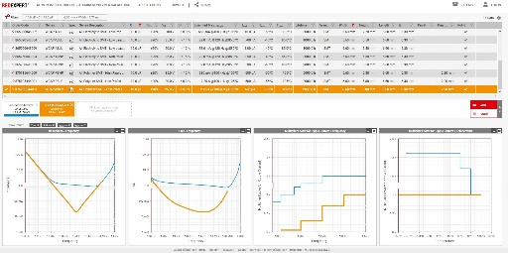
Image source: Würth Elektronik
Selecting components on the basis of real measurements – the RedExpert online platform gets better and better. A new feature: the cross-technology comparison of capacitors.

About the Würth Elektronik eiSos Group
Würth Elektronik eiSos Group is a manufacturer of electronic and electromechanical components for the electronics industry and a technology company that spearheads pioneering electronic solutions. Würth Elektronik eiSos is one of the largest European manufacturers of passive components and is active in 50 countries. Production sites in Europe, Asia and North America supply a growing number of customers worldwide.
The product range includes EMC components, inductors, transformers, RF components, varistors, capacitors, resistors, quartz crystals, oscillators, power modules, Wireless Power Transfer, LEDs, sensors, connectors, power supply elements, switches, push-buttons, connection technology, fuse holders and solutions for wireless data transmission.
The unrivaled service orientation of the company is characterized by the availability of all catalog components from stock without minimum order quantity, free samples and extensive support through technical sales staff and selection tools.
Through its technology partnership with the Audi Sport ABT Schaeffler Formula E Team and its support for the Formula Student racing series, the company demonstrates its innovative strength in eMobility
(www.we-speed-up-the-future.com).
Würth Elektronik is part of the Würth Group, the world market leader for assembly and fastening technology. The company employs 7,300 staff and generated sales of 822 million euros in 2019.
Würth Elektronik: more than you expect!
Further information at www.we-online.com

Further information:  Würth Elektronik eiSos GmbH & Co. KG  Sarah Hurst  Max-Eyth-Strasse 1  74638 Waldenburg  Germany  Phone: +49 7942 945-5186  E-mail: sarah.hurst@we-online.de  www.we-online.de | Press contact:  HighTech communications GmbH  Brigitte Basilio  Brunhamstrasse 21  81249 Munich  Germany  Phone: +49 89 500778-20  Telefax: +49 89 500778-77  E-mail: b.basilio@htcm.de  www.htcm.de

