PRESS RELEASE
Würth Elektronik expands its WL-SWTP LED series
Broad Selection of White LEDs
Waldenburg (Germany), 18 November 2020—Würth Elektronik has doubled its product range of SMT assembly white top view LEDs to 30 models. The 3014, 3030 and 5630 packages of the WL-SWTP product group have been expanded to include the "A series". These new LEDs in PLCC packages feature the best possible lumen per watt ratio and MacAdam binning, thus achieving the maximum homogeneity in color perception.
The A series (identified by an A at the end of the product code), as part of the WL-SWTP series, is one of the top LEDs available on the market with typical values from 175 lm/W. The long-life, slimline LEDs are suitable for many types of lamps, status displays, backlighting, industrial and consumer products for both indoor and outdoor use. They are characterized by a high color rendering index (CRI) and low energy consumption. The LEDs are available in five different color temperatures: Cool White (6000 K), Daylight (5000 K), Moonlight (4000 K), Warm White (3000 K) and Sunrise (2700 K). Using 3- and 5-step MacAdam binning, the ultimate color homogeneity can be achieved for each CCT group without compromising efficiency. Würth Elektronik provides developers with free samples. In addition, Würth Elektronik offers a design kit with free refilling, as well as demo boards for PLCC LEDs. Along with the entire product group, the highly efficient A series LEDs are now available from stock without minimum order quantities.

Available images
The following images can be downloaded from the Internet in printable quality: http://www.htcm.de/kk/wuerth

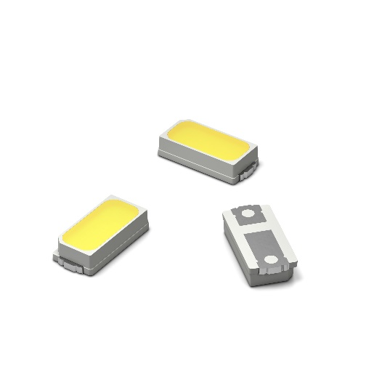Image source: Würth Elektronik  WL-SWTP SMT LED series in 3014 package | 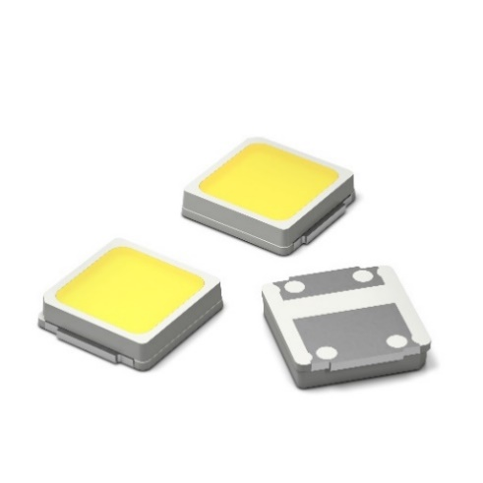Image source: Würth Elektronik  WL-SWTP SMT LED series in 3030 package

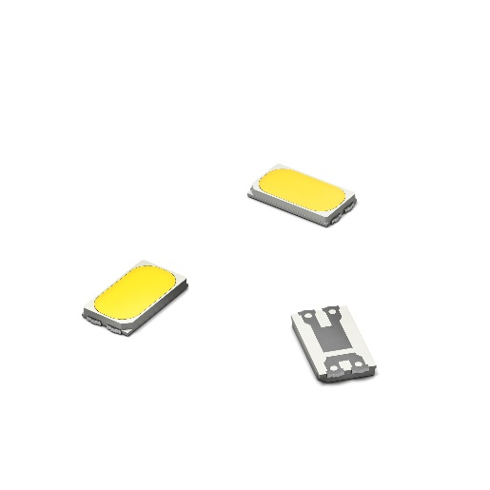Image source: Würth Elektronik
WL-SWTP SMT LED series in 5630 package

About the Würth Elektronik eiSos Group
Würth Elektronik eiSos Group is a manufacturer of electronic and electromechanical components for the electronics industry and a technology company that spearheads pioneering electronic solutions. Würth Elektronik eiSos is one of the largest European manufacturers of passive components and is active in 50 countries. Production sites in Europe, Asia and North America supply a growing number of customers worldwide.
The product range includes EMC components, inductors, transformers, RF components, varistors, capacitors, resistors, quartz crystals, oscillators, power modules, Wireless Power Transfer, LEDs, sensors, connectors, power supply elements, switches, push-buttons, connection technology, fuse holders and solutions for wireless data transmission.
The unrivaled service orientation of the company is characterized by the availability of all catalog components from stock without minimum order quantity, free samples and extensive support through technical sales staff and selection tools.
Through its technology partnership with the Audi Sport ABT Schaeffler Formula E Team and its support for the Formula Student racing series, the company demonstrates its innovative strength in eMobility
(www.we-speed-up-the-future.com).
Würth Elektronik is part of the Würth Group, the world market leader for assembly and fastening technology. The company employs 7,300 staff and generated sales of 822 million euros in 2019.
Würth Elektronik: more than you expect!
Further information at www.we-online.com

Further information:  Würth Elektronik eiSos GmbH & Co. KG  Sarah Hurst  Max-Eyth-Strasse 1  74638 Waldenburg  Germany  Phone: +49 7942 945-5186  E-mail: sarah.hurst@we-online.de  www.we-online.de | Press contact:  HighTech communications GmbH  Brigitte Basilio  Brunhamstrasse 21  81249 Munich  Germany  Phone: +49 89 500778-20  Telefax: +49 89 500778-77  E-mail: b.basilio@htcm.de  www.htcm.de

