PRESS RELEASE
Würth Elektronik introduces its WE-MK multilayer ceramic inductors
Space-Saving High-Frequency Inductors with Polarity Marking
Waldenburg (Germany), 17 September 2020 - Cost-effective RF coils integrated in a multilayer ceramic structure—with WE-MK, Würth Elektronik offers a wide range of SMT inductors with high self resonant frequency (up to f_{RES} > 10 GHz). WE-MK is available in three different sizes—0201, 0402 and 0603—as well as various inductance values from 1 nH up to 470 nH.
The WE-MK inductors have very stable inductance over the entire operating temperature range from -55 to +125°C with inductance tolerances of ±5% or ±0.3 nH (depending on inductance value, higher inductance values are percentage based). The inductance is suitable for various high-frequency circuit types and is the preferred component for the matching of antennas, for example. Here Würth Elektronik offers developers special support with an antenna matching service.
An extremely useful detail: The WE-MK components have polarity markings. This information allows a reduction in the mutual coupling between inductors placed close together.
All multilayer ceramic inductors from Würth Elektronik are available from stock. Free samples are available.

Available images
The following images can be downloaded from the Internet in printable quality: http://www.htcm.de/kk/wuerth

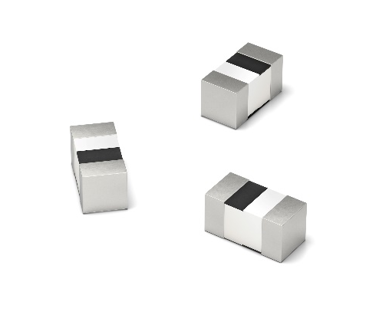Image source: Würth Elektronik
WE-MK Multilayer Ceramic Inductors

About the Würth Elektronik eiSos Group
Würth Elektronik eiSos Group is a manufacturer of electronic and electromechanical components for the electronics industry and a technology company that spearheads pioneering electronic solutions. Würth Elektronik eiSos is one of the largest European manufacturers of passive components and is active in 50 countries. Production sites in Europe, Asia and North America supply a growing number of customers worldwide.
The product range includes EMC components, inductors, transformers, RF components, varistors, capacitors, resistors, quartz crystals, oscillators, power modules, Wireless Power Transfer, LEDs, sensors, connectors, power supply elements, switches, push-buttons, connection technology, fuse holders and solutions for wireless data transmission.
The unrivaled service orientation of the company is characterized by the availability of all catalog components from stock without minimum order quantity, free samples and extensive support through technical sales staff and selection tools.
Through its technology partnership with the Audi Sport ABT Schaeffler Formula E Team and its support for the Formula Student racing series, the company demonstrates its innovative strength in eMobility
(www.we-speed-up-the-future.com).
Würth Elektronik is part of the Würth Group, the world market leader for assembly and fastening technology. The company employs 7,300 staff and generated sales of 822 million euros in 2019.
Würth Elektronik: more than you expect!
Further information at www.we-online.com

Further information:  Würth Elektronik eiSos GmbH & Co. KG  Sarah Hurst  Max-Eyth-Strasse 1  74638 Waldenburg  Germany  Phone: +49 7942 945-5186  E-mail: sarah.hurst@we-online.de  www.we-online.de | Press contact:  HighTech communications GmbH  Brigitte Basilio  Brunhamstrasse 21  81249 Munich  Germany  Phone: +49 89 500778-20  Telefax: +49 89 500778-77  E-mail: b.basilio@htcm.de  www.htcm.de

