PRESS RELEASE

Formula E technology partner Würth Elektronik
After the season is before the season
Waldenburg (Germany), August 21, 2020 - The Audi Sport ABT Schaeffler racing team, which has been supported by Würth Elektronik since the beginning of Formula E, has ended a season that was made more difficult by the pandemic. In the last races in Berlin from August 5 to 13, 2020, René Rast, the new driver at the side of former Formula E world champion Lucas di Grassi, made a successful start to Formula E. With good placings, the multiple DTM world champion and long-time Audi Sport factory driver also proved his driving class in the racing car. Technology partner Würth Elektronik is already looking forward to the coming season. The new racing car FE07 is already being developed at full speed.
"From a technical point of view Formula E becomes more exciting with every season. More and more individual developments of the teams get into the racing cars. For the FE07, a separate powertrain is being developed for the first time - an exciting topic for us as a supplier of components for power electronics", says Oliver Opitz, Vice President of the Wireless Connectivity & Sensors Division and Technical Coordinator Formula E at Würth Elektronik eiSos. "Since the very first race of this attractive racing series, we have been involved as technology partner. We see electric mobility as an important driver of innovation, whose sporty version we want to promote - as a kind of racing test laboratory, so to speak".
The REDCUBE series of high-current connectors, which have been specially developed for the race track, has been in use in the car since Season 2. In addition, Würth Elektronik developed specific high-current high-voltage chokes and an innovative gate drive transformer for energy-saving, highly efficient electronics in electrical applications. The components are constantly tested under harsh conditions in the "Test Laboratory Race Track" in order to optimize them and adapt them to the requirements for a broad use in series applications in electric mobility.
"What makes me particularly happy: From next season on, Sat.1 will broadcast Formula E. This will give a further boost to e-mobility and makes us happy as a Formula E technology partner as well as an enabler of numerous e-mobility projects", adds Alexander Gerfer, CTO of the Würth Elektronik eiSos Group.

The commitment of Würth Elektronik
Würth Elektronik sees itself as a partner of developers in the electronics industry and is committed to supporting innovative start-ups. Based on its self-image as a technology enabler for future-oriented electronic solutions, the company cultivates eMobility technology partnerships under the motto "WE speed up the future".

Available images
The following images can be downloaded from the Internet in printable quality: http://www.htcm.de/kk/wuerth
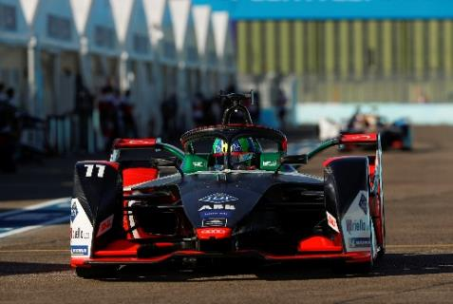  Image source:  Audi Media Center  Lucas di Grassi at the final races of Formula E in Berlin | 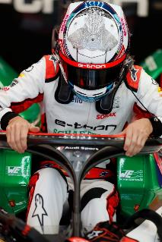  Image source:  Audi Media Center  René Rast, multiple world champion in the DTM, has entered Formula E.

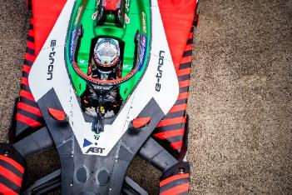  Image source: Audi Media Center  René Rast in Audi Sport ABT Schaeffler Formula E racing car | 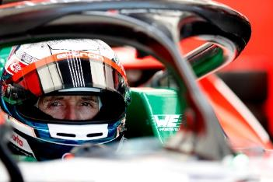  Image source: Audi Media Center  René Rast, the new driver in Team Audi Sport ABT Schaeffler

About the Würth Elektronik eiSos Group
Würth Elektronik eiSos Group is a manufacturer of electronic and electromechanical components for the electronics industry and a technology company that spearheads pioneering electronic solutions. Würth Elektronik eiSos is one of the largest European manufacturers of passive components and is active in 50 countries. Production sites in Europe, Asia and North America supply a growing number of customers worldwide.
The product range includes EMC components, inductors, transformers, RF components, varistors, capacitors, resistors, quartz crystals, oscillators, power modules, Wireless Power Transfer, LEDs, sensors, connectors, power supply elements, switches, push-buttons, connection technology, fuse holders and solutions for wireless data transmission.
The unrivaled service orientation of the company is characterized by the availability of all catalog components from stock without minimum order quantity, free samples and extensive support through technical sales staff and selection tools.
Through its technology partnership with the Audi Sport ABT Schaeffler Formula E Team and its support for the Formula Student racing series, the company demonstrates its innovative strength in eMobility
(www.we-speed-up-the-future.com).
Würth Elektronik is part of the Würth Group, the world market leader for assembly and fastening technology. The company employs 7,300 staff and generated sales of 822 million euros in 2019.
Würth Elektronik: more than you expect!
Further information at www.we-online.com

Further information:  Würth Elektronik eiSos GmbH & Co. KG  Sarah Hurst  Max-Eyth-Strasse 1  74638 Waldenburg  Germany  Phone: +49 7942 945-5186  E-mail: sarah.hurst@we-online.de  www.we-online.de | Press contact:  HighTech communications GmbH  Brigitte Basilio  Brunhamstrasse 21  81249 Munich  Germany  Phone: +49 89 500778-20  Telefax: +49 89 500778-77  E-mail: b.basilio@htcm.de  www.htcm.de

