PRESS RELEASE
Würth Elektronik presents its WE-AGDT transformers for SiC MOSFET gate drivers
Part of a High-Performance Power Supply
Waldenburg (Germany), 1 December 2020—The WE-AGDT series makes a new SMT assembly transformer available, which, at the same time, is part of a power supply solution developed by Würth Elektronik for demanding gate control of SiC MOSFETs. The innovative WE-AGDT is a compact transformer in an EP7 package. It features a wide input voltage range from 9 to 36 V, a high saturation current of 4.5 A, as well as very low leakage inductance, and a very low capacitance of 6.8 pF between the windings. This gives rise to high common-mode transient immunity (CMTI) of the gate driver system.
The WE-AGDT series comprises six transformers, each optimized for its respective reference design. Thanks to their two separate secondary windings, they allow both bipolar (+15 V, -4 V) and unipolar (+15 V to +20 V, 0 V) output voltages. The input voltage of 9 to 36 V achieves a maximum output power of 3 to 6 W. WE-AGDT transformers are optimized for SiC applications, but are also suitable for optimally controlling IGBT and power MOSFETs, and, given a suitable DC-DC converter, even for high-voltage GaN FETs. Würth Elektronik's reference design for a compact, galvanically isolated DC-DC converter for SiC MOSFET gate drivers is available at www.we-online.com/RD001.
WE-AGDT – Auxiliary Gate Drive Transformer
"With the increasing spread of power semiconductor devices in silicon carbide technology, which work at switching frequencies above 100 kHz, their gate control requirements are becoming more and more sophisticated. With the WE-AGDT series and the associated reference design, we have developed a solution that is as innovative as it is reliable, allowing developers to easily implement a compact, efficient and flexible supply with up to 6 W output power," says Eleazar Falco, Application Engineer at Würth Elektronik eiSos.
WE-AGDT is available from stock without a minimum order quantity. On request, free samples are made available to developers.
Further information at www.we-online.com/agdt

Available images
The following images can be downloaded from the Internet in printable quality: http://www.htcm.de/kk/wuerth
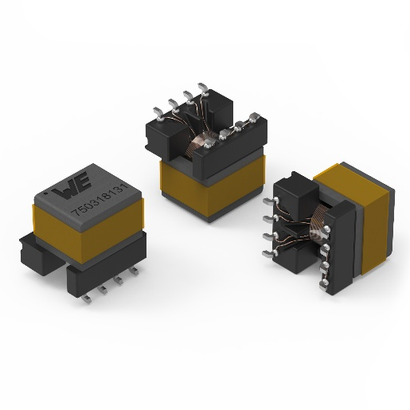
Image source: Würth Elektronik
WE-AGDT transformers

About the Würth Elektronik eiSos Group
Würth Elektronik eiSos Group is a manufacturer of electronic and electromechanical components for the electronics industry and a technology company that spearheads pioneering electronic solutions. Würth Elektronik eiSos is one of the largest European manufacturers of passive components and is active in 50 countries. Production sites in Europe, Asia and North America supply a growing number of customers worldwide.
The product range includes EMC components, inductors, transformers, RF components, varistors, capacitors, resistors, quartz crystals, oscillators, power modules, Wireless Power Transfer, LEDs, sensors, connectors, power supply elements, switches, push-buttons, connection technology, fuse holders and solutions for wireless data transmission.
The unrivaled service orientation of the company is characterized by the availability of all catalog components from stock without minimum order quantity, free samples and extensive support through technical sales staff and selection tools.
Through its technology partnership with the Audi Sport ABT Schaeffler Formula E Team and its support for the Formula Student racing series, the company demonstrates its innovative strength in eMobility
(www.we-speed-up-the-future.com).
Würth Elektronik is part of the Würth Group, the world market leader for assembly and fastening technology. The company employs 7,300 staff and generated sales of 822 million euros in 2019.
Würth Elektronik: more than you expect!
Further information at www.we-online.com

Further information:  Würth Elektronik eiSos GmbH & Co. KG  Sarah Hurst  Max-Eyth-Strasse 1  74638 Waldenburg  Germany  Phone: +49 7942 945-5186  E-mail: sarah.hurst@we-online.de  www.we-online.de | Press contact:  HighTech communications GmbH  Brigitte Basilio  Brunhamstrasse 21  81249 Munich  Germany  Phone: +49 89 500778-20  Telefax: +49 89 500778-77  E-mail: b.basilio@htcm.de  www.htcm.de

