PRESS RELEASE
Würth Elektronik expands its LED range with power-saving WL-SMTW
Colors for Feeding Plants
Waldenburg (Germany), 22 October 2020 – SMT mountable LEDs in a 2835 package extend Würth Elektronik extensive range of horticulture LEDs. The three WL-SMTW series LEDs emit light of the wavelengths 450 nm (Deep Blue), 660 nm (Hyper Red) and 730 nm (Far Red) – ideal for applications controlling plant growth through specific light mixtures. Besides vertical farming and lighting in greenhouses, thanks to their efficiency, small size and minimal heat generation the WL-SMTWs, combined with the manufacturer’s other LEDs are also suitable for classic LED applications like displays and backlighting.
A photosynthetic photon flux of up to 0.94 µmol/s at a current of just 150 mA, and the small size (2.8 x 3.5 x 0.8 mm) mean you don’t even need three mid-power LEDs to replace a high-power LED. This allows larger-scale and more homogeneous lighting applications to be realized. With its Development Kit, Würth Elektronik is there for the developers of horticultural lighting solutions, to whom the WL-SMTW product is particularly directed. In the REDEXPERT online simulation platform there is a "Horticulator" in which lighting recipes can be created (https://redexpert.we-online.com/redexpert/#/smodule/26). All Würth Elektronik LEDs are available from stock. Free LED samples are provided.
Cooperation with research institutions
"Our new LED series offers excellent value for money and high luminosity – the Deep Blue LED is unique on the market in this respect," Harun Özgür, Division Manager, Optoelectronics at Würth Elektronik eiSos GmbH & Co. KG expresses his satisfaction about the new addition to horticulture LED range (http://www.we-online.com/leditgrow). Johann Waldherr, agricultural scientist in Würth Elektronik’s LED team, explains: "The blue light plays a role in many plant processes, such as the formation of secondary metabolites. The illumination with spectra individually created from the different wavelengths of monochromatic LEDs becomes even more efficient with the new mid-power LEDs, yet at the same time more homogeneous. These three LEDs form a basic framework in combination with other LEDs of the WL-SMTW, WL-SWTP and WL-SMDC series, so it is possible to create specific lighting recipes for a wide range of the horticulturist’s quality parameters, such as more blossoms, more fruit, more biomass, more vitamins, and so on. As our partners’ innovation partner, we conduct intensive research and we have established a competence network with research institutions, sharing our knowledge with our customers.
For example, Würth Elektronik maintains research cooperations with the Dürnast Greenhouse Laboratory Center at the Technical University of Munich along with other research institutions.

Available images
The following images can be downloaded from the Internet in printable quality: http://www.htcm.de/kk/wuerth
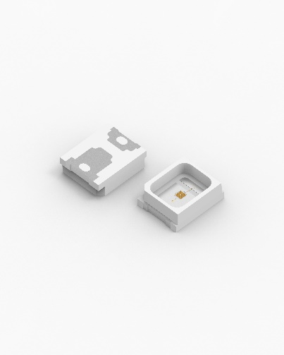Image source: Würth Electronics  WL-SMTW series LEDs | 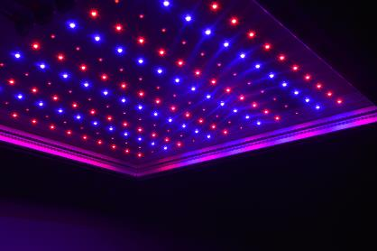  Image source: Würth Electronics  Horticulture Lighting at the wavelengths 450 nm, 660 nm, and 730 nm

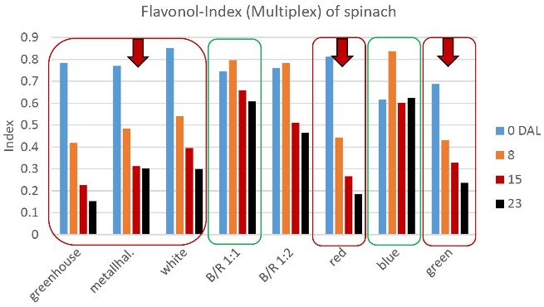
Image source: Experiment TUM / Würth Elektronik
Blue light promotes the accumulation of secondary metabolites in the plant.

Available videos
You can find a video on this topic on our YouTube channel:
https://youtu.be/HIF-uNAQm5Y
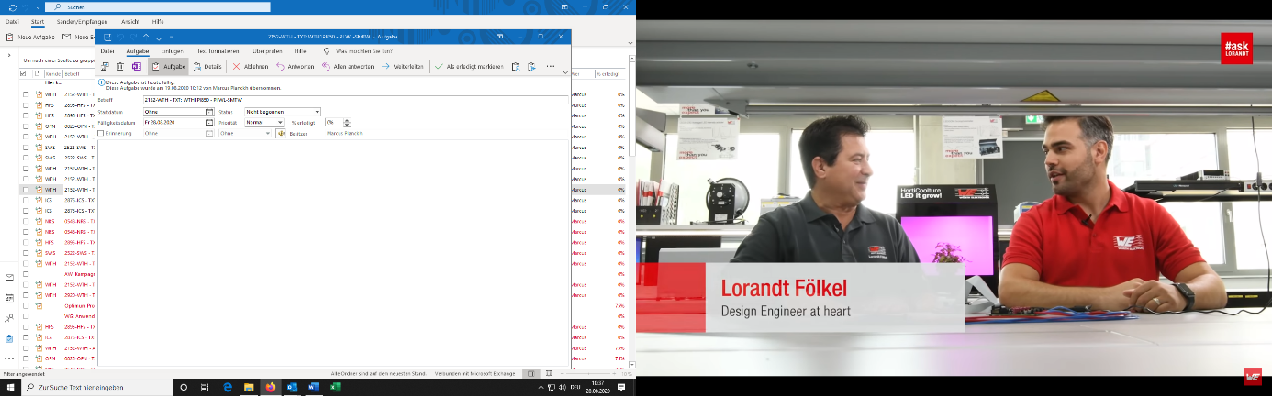Source: Würth Elektronik
Lorandt Fölkel talks to Harun Özgür about horticulture LEDs.

About the Würth Elektronik eiSos Group
Würth Elektronik eiSos Group is a manufacturer of electronic and electromechanical components for the electronics industry and a technology company that spearheads pioneering electronic solutions. Würth Elektronik eiSos is one of the largest European manufacturers of passive components and is active in 50 countries. Production sites in Europe, Asia and North America supply a growing number of customers worldwide.
The product range includes EMC components, inductors, transformers, RF components, varistors, capacitors, resistors, quartz crystals, oscillators, power modules, Wireless Power Transfer, LEDs, sensors, connectors, power supply elements, switches, push-buttons, connection technology, fuse holders and solutions for wireless data transmission.
The unrivaled service orientation of the company is characterized by the availability of all catalog components from stock without minimum order quantity, free samples and extensive support through technical sales staff and selection tools.
Through its technology partnership with the Audi Sport ABT Schaeffler Formula E Team and its support for the Formula Student racing series, the company demonstrates its innovative strength in eMobility
(www.we-speed-up-the-future.com).
Würth Elektronik is part of the Würth Group, the world market leader for assembly and fastening technology. The company employs 7,300 staff and generated sales of 822 million euros in 2019.
Würth Elektronik: more than you expect!
Further information at www.we-online.com

Further information:  Würth Elektronik eiSos GmbH & Co. KG  Sarah Hurst  Max-Eyth-Strasse 1  74638 Waldenburg  Germany  Phone: +49 7942 945-5186  E-mail: sarah.hurst@we-online.de  www.we-online.de | Press contact:  HighTech communications GmbH  Brigitte Basilio  Brunhamstrasse 21  81249 Munich  Germany  Phone: +49 89 500778-20  Telefax: +49 89 500778-77  E-mail: b.basilio@htcm.de  www.htcm.de

