PRESS RELEASE
Würth Elektronik sponsors students’ solar car projects
Always a winner, no matter what the results
Waldenburg (Germany), 8 October 2020 – Under the sponsorship of Würth Elektronik eiSos GmbH & Co. KG, the Team Sonnenwagen Aachen once again took part in the iLumen European Solar Challenge (19-20 September 2020) – together with three other teams sponsored by Würth Elektronik Nederland B.V. In the 24-hour race in Zolder, Belgium, Covestro Sonnenwagon was the only German team in the race to cross the finish line with its solar powered car. The solar racing team of the Rheinisch-Westfälische Technische Hochschule Aachen (RWTH - Aachen Technical University) includes more than just a silver sponsor in Würth Elektronik; their technology partner provides the students with special training, technical support, and many electronic and electromechanical components.
Sponsored by WE’s Dutch colleagues, the Solar Team Twente, winner of the last two years, won second place after crossing the finishing line just behind the Belgian Agoria Solar Team. The Top Dutch Solar Racing team came in third place overall. Another project sponsored by Würth Elektronik B.V. is the Solar Team Eindhoven; the only team to put two Cruiser Class cars on the starting grid. Cruiser Class cars are solar-powered vehicles crewed by two people or more.
“A kerb weight of 164 kg, a top speed of 144 km/h, speeds over 90 km/h with a performance of just 1 kW, and as much as 6 kW recuperation performance during a race – from the technical viewpoint the solar-powered cars are an engineer’s dream, since the students exploit the energy efficiency to the utmost. With our technology partnership program we support budding engineers, people who know how to develop sustainable technical solutions,” says an enthusiastic Alexander Gerfer, CTO of the Würth Elektronik eiSos Group. In the week before the iLumen European Solar Challenge, he paid a visit to the Team Sonnenwagen Aachen at the test circuit, accompanied by Regional Manager Henrik Küskens and Marion Wagner, Strategy & Coordination Manager Group Technology Partnerships eMotorsports. Würth Elektronik eiSos’ best known technology partnership programme is with the Audi Sport ABT Schaeffler Formula E racing team.
Technology partnership programs
“Today more than ever, we consider e-mobility to be an essential driver of innovation, and we’re glad to be engaged here as a sponsor of start-ups, as well as in technology partnership schemes, from Formula E all the way to a broad spectrum of university projects,”,says Gerfer. “We’ve been a proud sponsor of the Team Sonnenwagen Aachen for over three years now, and not just in the form of materials. Next month, we’ll be continuing our support in the shape of six workshops on EMC topics at the RWTH Aachen.”

Available images
The following images can be downloaded from the Internet in printable quality: http://www.htcm.de/kk/wuerth
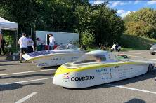Image source: Würth Elektronik  The new Covestro Sonnenwagen (in the foreground) came in fifth place at the iLumen European Solar Challenge 2020 24-hour race. Team Sonnenwagen Aachen already reached sixth place with this car in the Bridgestone World Solar Challenge 2019. | 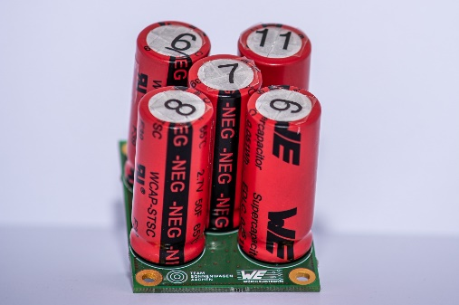  Image source: Würth Elektronik  Inside the Sonnenwagen: a battery-management system with capacitors supplied by Würth Elektronik.
  Image source: Würth Elektronik  Already proven in the Formula E circus, Würth Elektronik technology occupies a prominent place on the circuit board: REDCUBE terminals for high current transmission – extremely vibration-resistant thanks to press-fit technology. | 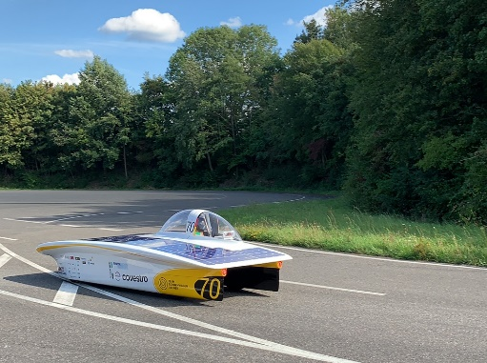  Image source: Würth Elektronik  Third place in 2018, and a decent eighth place this year: the Sonnenwagen 1.0, Team Sonnenwagen Aachen’s very first project.

About the Würth Elektronik eiSos Group
Würth Elektronik eiSos Group is a manufacturer of electronic and electromechanical components for the electronics industry and a technology company that spearheads pioneering electronic solutions. Würth Elektronik eiSos is one of the largest European manufacturers of passive components and is active in 50 countries. Production sites in Europe, Asia and North America supply a growing number of customers worldwide.
The product range includes EMC components, inductors, transformers, RF components, varistors, capacitors, resistors, quartz crystals, oscillators, power modules, Wireless Power Transfer, LEDs, sensors, connectors, power supply elements, switches, push-buttons, connection technology, fuse holders and solutions for wireless data transmission.
The unrivaled service orientation of the company is characterized by the availability of all catalog components from stock without minimum order quantity, free samples and extensive support through technical sales staff and selection tools.
Through its technology partnership with the Audi Sport ABT Schaeffler Formula E Team and its support for the Formula Student racing series, the company demonstrates its innovative strength in eMobility
(www.we-speed-up-the-future.com).
Würth Elektronik is part of the Würth Group, the world market leader for assembly and fastening technology. The company employs 7,300 staff and generated sales of 822 million euros in 2019.
Würth Elektronik: more than you expect!
Further information at www.we-online.com

Further information:  Würth Elektronik eiSos GmbH & Co. KG  Sarah Hurst  Max-Eyth-Strasse 1  74638 Waldenburg  Germany  Phone: +49 7942 945-5186  E-mail: sarah.hurst@we-online.de  www.we-online.de | Press contact:  HighTech communications GmbH  Brigitte Basilio  Brunhamstrasse 21  81249 Munich  Germany  Phone: +49 89 500778-20  Telefax: +49 89 500778-77  E-mail: b.basilio@htcm.de  www.htcm.de

