PRESS RELEASE
Würth Elektronik awarded by Mouser
Successful sales channel
Waldenburg (Germany), 20 October 2020 – Mouser Electronics has awarded Joe Haukos of Würth Elektronik eiSos with the 2020 Best-in-Class Award. The honor was the highlight of a joint quarterly review, which highlighted the great success of Würth Elektronik products in the Mouser range: Würth Elektronik is one of the most prominent rising suppliers at Mouser and has been able to increase sales by more than 25% compared to the previous year.
Jeff Newell, Senior Vice President of Products at Mouser Electronics, honored Joe Haukos, Distribution Manager Americas at Würth Elektronik eiSos, with the 2020 Best-in-Class Award. The award is presented to an individual from the large group of supplier partners of the electronics distributor who stands out in five main criteria: Strategically partnering with the Mouser team, promoting product lines and working together on new product introductions, finding creative solutions to grow market share mutually for both companies, maximizing Mouser’s unique value proposition within their own businesses and supporting Mouser within their organizations. Würth Elektronik is proud that this is the first time this award has been presented to an employee. "Joe and the entire Distribution Sales Team have earned this award through their dedication and creativity over the years. We are very grateful to our partner Mouser Electronics for recognizing Joe Haukos' achievements and showing that people still make the difference in a successful business relationship, agrees Lars Fahrbach, Vice President Global Distribution & New Markets.

Available images
The following images can be downloaded from the Internet in printable quality: http://www.htcm.de/kk/wuerth
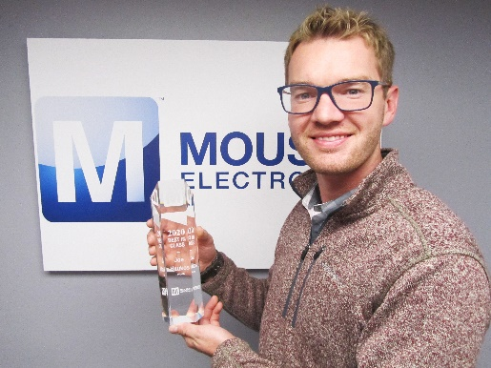
Image source: Würth Elektronik
Joe Haukos, Distribution Manager Americas at Würth Elektronik eiSos, with the Best-in-Class Award 2020 from Mouser Electronics

About the Würth Elektronik eiSos Group
Würth Elektronik eiSos Group is a manufacturer of electronic and electromechanical components for the electronics industry and a technology company that spearheads pioneering electronic solutions. Würth Elektronik eiSos is one of the largest European manufacturers of passive components and is active in 50 countries. Production sites in Europe, Asia and North America supply a growing number of customers worldwide.
The product range includes EMC components, inductors, transformers, RF components, varistors, capacitors, resistors, quartz crystals, oscillators, power modules, Wireless Power Transfer, LEDs, sensors, connectors, power supply elements, switches, push-buttons, connection technology, fuse holders and solutions for wireless data transmission.
The unrivaled service orientation of the company is characterized by the availability of all catalog components from stock without minimum order quantity, free samples and extensive support through technical sales staff and selection tools.
Through its technology partnership with the Audi Sport ABT Schaeffler Formula E Team and its support for the Formula Student racing series, the company demonstrates its innovative strength in eMobility
(www.we-speed-up-the-future.com).
Würth Elektronik is part of the Würth Group, the world market leader for assembly and fastening technology. The company employs 7,300 staff and generated sales of 822 million euros in 2019.
Würth Elektronik: more than you expect!
Further information at www.we-online.com

Further information:  Würth Elektronik eiSos GmbH & Co. KG  Sarah Hurst  Max-Eyth-Strasse 1  74638 Waldenburg  Germany  Phone: +49 7942 945-5186  E-mail: sarah.hurst@we-online.de  www.we-online.de | Press contact:  HighTech communications GmbH  Brigitte Basilio  Brunhamstrasse 21  81249 Munich  Germany  Phone: +49 89 500778-20  Telefax: +49 89 500778-77  E-mail: b.basilio@htcm.de  www.htcm.de

