PRESS RELEASE
Würth Elektronik introduces its WSEN-HIDS humidity sensor
Small, Economical and Accurate
Waldenburg (Germany), 5 November 2020—Würth Elektronik has developed a micro-electro-mechanical system (MEMS) sensor only 2 x 2 x 0.9 mm in size. Thanks to its low energy requirement and its calibrated and temperature-compensated digital output, the sensor measures humidity and temperature with long-term stability. The WSEN-HIDS humidity sensor is based on advanced MEMS technology: A dielectric polymer absorbs or releases water molecules in proportion to the relative humidity in the surroundings, thereby changing the permeability of a capacitor structure. The humidity sensor with integrated analog-digital converter and temperature sensor can be connected to commonly used microcontrollers via an I²C or SPI interface. With the help of the software development kit, which is also available, there is no faster/easier way to individually set data rates and use the interrupt pin.
Alongside classical applications, such as heating, ventilation, air conditioning, building automation, and cooling systems, thanks to its small size and minimized energy requirement, the WSEN-HIDS humidity sensor is also suitable for dataloggers, as well as stationary and portable IoT applications. For modern applications, Würth Elektronik provides developers with an evaluation board. The MEMS sensor delivers calibrated measurement results with superb accuracy of ±3.5% RH in the 20% to 80% RH humidity range. The sensor outputs at a data rate in the millisecond range. Condensate forming on the surface of the polymer structure can be removed again by activating a built-in heater—so the sensor can generate measured data again within a very short time. The operating temperature range of the robust sensor is -40 to +120°C.
Easy to integrate
"With WSEN-HIDS, we are pleased to be able to offer one of the most innovative humidity and temperature sensors. The sensor promotes rapid terminal device development because developers can use a digital output directly via I²C or SPI and do not have to worry about calibration or temperature compensation," explains Vinod Kumar Ramu, Product Manager at Würth Elektronik eiSos. "Very practical: The sensor’s interrupt pin can also be used to wake up the microcontroller if the humidity changes. This is ideal for economical and low-maintenance monitoring functions." The current consumption of the humidity sensor is 8.9 µA in continuous operation with measurement data available every second. Using a CR2032 button cell with 230 mAh capacity, this corresponds to a battery life of about three years. If the sampling rate is reduced, applications stay maintenance-free even longer.
"It is the ideal solution for every manufacturer of terminal devices to integrate this miniaturized WSEN-HIDS sensor into their application. The possibility of data evaluation for humidity and temperature in case of a complaint concerning the terminal device and the knowledge of what was "going on" with it, means the investment pays off very quickly," says Dr. Michael Brauer, Head of Product Management of the Wireless Connectivity & Sensors Division at Würth Elektronik eiSos.
The sensor is now available from stock without a minimum order quantity as a belt section or tape & reel package.

Available images
The following images can be downloaded from the Internet in printable quality: http://www.htcm.de/kk/wuerth
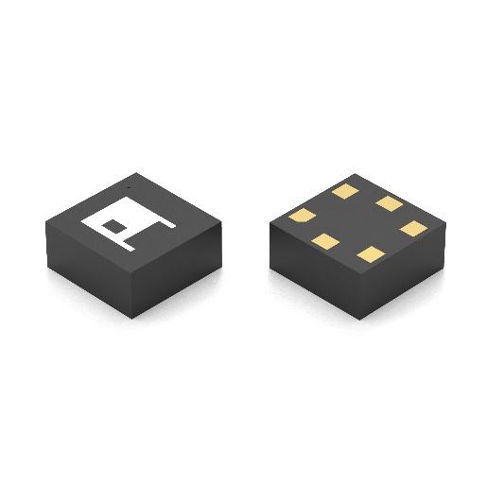Image source: Würth Elektronik
WSEN-HIDS humidity sensor

About the Würth Elektronik eiSos Group
Würth Elektronik eiSos Group is a manufacturer of electronic and electromechanical components for the electronics industry and a technology company that spearheads pioneering electronic solutions. Würth Elektronik eiSos is one of the largest European manufacturers of passive components and is active in 50 countries. Production sites in Europe, Asia and North America supply a growing number of customers worldwide.
The product range includes EMC components, inductors, transformers, RF components, varistors, capacitors, resistors, quartz crystals, oscillators, power modules, Wireless Power Transfer, LEDs, sensors, connectors, power supply elements, switches, push-buttons, connection technology, fuse holders and solutions for wireless data transmission.
The unrivaled service orientation of the company is characterized by the availability of all catalog components from stock without minimum order quantity, free samples and extensive support through technical sales staff and selection tools.
Through its technology partnership with the Audi Sport ABT Schaeffler Formula E Team and its support for the Formula Student racing series, the company demonstrates its innovative strength in eMobility
(www.we-speed-up-the-future.com).
Würth Elektronik is part of the Würth Group, the world market leader for assembly and fastening technology. The company employs 7,300 staff and generated sales of 822 million euros in 2019.
Würth Elektronik: more than you expect!
Further information at www.we-online.com

Further information:  Würth Elektronik eiSos GmbH & Co. KG  Sarah Hurst  Max-Eyth-Strasse 1  74638 Waldenburg  Germany  Phone: +49 7942 945-5186  E-mail: sarah.hurst@we-online.de  www.we-online.de | Press contact:  HighTech communications GmbH  Brigitte Basilio  Brunhamstrasse 21  81249 Munich  Germany  Phone: +49 89 500778-20  Telefax: +49 89 500778-77  E-mail: b.basilio@htcm.de  www.htcm.de

