PRESS RELEASE
Würth Elektronik presents its Wireless Connectivity & Sensors Product Guide
Radio and Sensors Modules for IoT and Industrial Applications
Waldenburg (Germany), 16 December 2020—With its new catalog for radio modules and sensors, Würth Elektronik presents a whole series of new products with innovative details. For example, the component manufacturer offers many variants or operating modes with extremely low energy consumption to make increased use of combinations of sensors and radio modules in low-maintenance, decentralized IoT applications. Highlights of the 2020/21 Product Guide: the product family of calibrated MEMS-based sensors recently completed with a humidity sensor, and the proprietary Thyone-I radio module.
The Wireless Connectivity & Sensors Product Guide, available at www.we-online.com/wcs-product-guide, offers additional technical launches and provides plenty of basic and detailed knowledge, on radio protocols for example. This and other information makes it easier for developers to select the products presented in the catalog to match their applications. Important for developers: All products are available from stock without a minimum order quantity and in addition Würth Elektronik offers very extensive design-in support with tools and in-house experts.
Signal position and status
The new catalog devotes an entire chapter to positioning. Elara and Erinome—the GNSS module series—allow convenient implementation of satellite navigation in products. All modules can be operated in low-power mode and offer I²C and SPI alongside the established UART interface.
Another focus is on the recently launched WSEN-HIDS humidity sensor. The sensor is robust, calibrated and temperature compensated. Thanks to an interrupt pin, it can be used directly for monitoring. "With all our sensors, we ensure they provide directly usable data, including processed data, in order to keep the developers’ integration workload as low as possible," explains Michael Brauer, Head of Product Management of the Wireless Connectivity & Sensors Division at Würth Elektronik eiSos. "Combined with our wide ranging compact and economical wireless solutions, the sensors can be used extremely efficiently in IoT and industrial networks."
Radio modules for Smart Factory, Smart Home, Logistics and much more
With Thyone-I, Würth Elektronik shows what is possible in the 2.4 GHz band: a range of up to 750 m and an end-to-end payload throughput of up to 400 kbps. This is enabled by the extremely versatile and easy-to-configure WE-ProWare firmware with its lean and powerful radio protocol. And what’s more: The wireless modules can be easily converted to other protocols such as Wirepas, which is becoming increasingly popular among developers.
Enabling innovations
"The products presented in the Wireless Connectivity & Sensors Product Guide and the support we offer in this area clearly demonstrates how we, as a component manufacturer, strive to promote innovative product developments—whether through useful details such as interfaces, an energy-saving mode, or through the simple fact that we serve developers and start-ups otherwise not served by other manufacturers on account of their small quantities", explains Oliver Opitz, Vice President at Würth Elektronik.

Available images
The following images can be downloaded from the Internet in printable quality: http://www.htcm.de/kk/wuerth
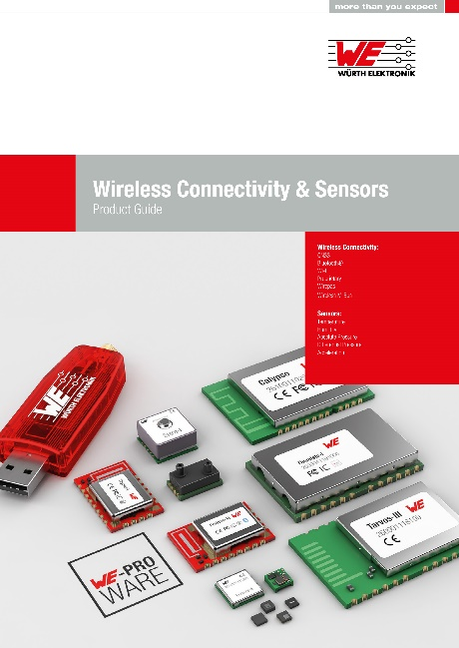
Image source: Würth Elektronik
Wireless Connectivity & Sensors Product Guide

About the Würth Elektronik eiSos Group
Würth Elektronik eiSos Group is a manufacturer of electronic and electromechanical components for the electronics industry and a technology company that spearheads pioneering electronic solutions. Würth Elektronik eiSos is one of the largest European manufacturers of passive components and is active in 50 countries. Production sites in Europe, Asia and North America supply a growing number of customers worldwide.
The product range includes EMC components, inductors, transformers, RF components, varistors, capacitors, resistors, quartz crystals, oscillators, power modules, Wireless Power Transfer, LEDs, sensors, connectors, power supply elements, switches, push-buttons, connection technology, fuse holders and solutions for wireless data transmission.
The unrivaled service orientation of the company is characterized by the availability of all catalog components from stock without minimum order quantity, free samples and extensive support through technical sales staff and selection tools.
Through its technology partnership with the Audi Sport ABT Schaeffler Formula E Team and its support for the Formula Student racing series, the company demonstrates its innovative strength in eMobility
(www.we-speed-up-the-future.com).
Würth Elektronik is part of the Würth Group, the world market leader for assembly and fastening technology. The company employs 7,300 staff and generated sales of 822 million euros in 2019.
Würth Elektronik: more than you expect!
Further information at www.we-online.com

Further information:  Würth Elektronik eiSos GmbH & Co. KG  Sarah Hurst  Max-Eyth-Strasse 1  74638 Waldenburg  Germany  Phone: +49 7942 945-5186  E-mail: sarah.hurst@we-online.de  www.we-online.de | Press contact:  HighTech communications GmbH  Brigitte Basilio  Brunhamstrasse 21  81249 Munich  Germany  Phone: +49 89 500778-20  Telefax: +49 89 500778-77  E-mail: b.basilio@htcm.de  www.htcm.de

