PRESS RELEASE
Würth Elektronik publishes its Electronic Components 2020/2021 catalog
Passive Components, Optoelectronics and Power Modules
Waldenburg (Germany), 24 November 2020—With “Electronic Components 2020/2021” Würth Elektronik publishes an updated supplement to its general catalog. Besides a series of innovative new products, there is background and basic knowledge about EMC for high-frequency applications, gate driver circuits, single pair Ethernet, laser and infrared LEDs, as well as additional information. Practical application examples support the use of the components.
Components for gate driver circuits are another important topic in the new catalog. With the WE-AGDT transformer series and the associated reference design, Würth Elektronik offers a bipolar and galvanically isolated high-performance power supply customized for SiC MOSFETs. The new arrivals in the WE-CST current sense transformers product family are also included in this reference design. Relevant online information is found under www.we-online.com/agdt.
The additions to the signal transformer (WE-STST), LAN transformer (WE-LAN AQ) and filtered RJ45 jacks (WE-RJ45) product groups are interesting for developers of signal transmission and communication solutions. New high-frequency shielding cabinets for high frequency applications address the complex EMC challenges in this area. New quartz crystals and oscillators (WE-XTAL & SPXO) make up another part of the catalog. The opto-coupler series has also been expanded. The Vertical Cavity Surface Emitting Laser (WL-VCSL) is celebrating its debut; with this product release, the manufacturer Würth Elektronik expands its range of products to a new market segment.
Growth in the high current range
Many product groups have been extended by new designs: such as the WE-HCF, WE-HCFT and WE-HCM series of high current inductors as well as the WE-PD series of SMT storage chokes. There is growth in the wireless power domain with transmitter coils, especially the high-power transmitter coils, as well as in coils that support NFC communication, in addition to inductive charging processes.
The "Electronic Components 2020/2021" catalog is available for download at www.we-online.com/eisoscatalog. Links and QR codes in the pdf or print version (www.we-online.com/catalogorder) lead to further online information, such as webinars or simulations in the REDEXPERT simulation software.
All products in the catalog are available from stock without a minimum order quantity; free samples are available.

Available images
The following images can be downloaded from the Internet in printable quality: http://www.htcm.de/kk/wuerth
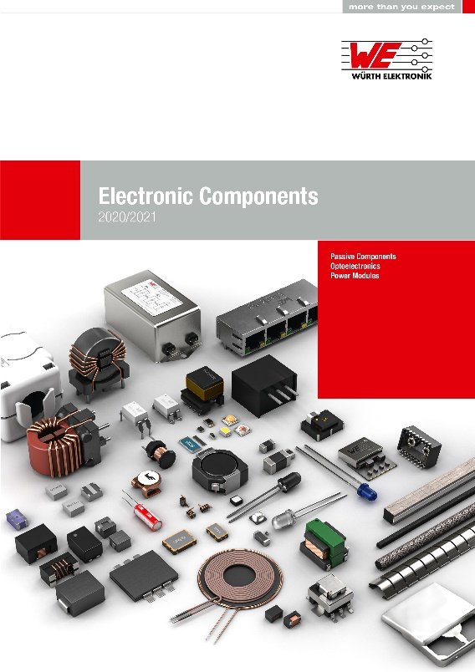
Image source: Würth Elektronik
Electronic Components 2020/2021 catalog

About the Würth Elektronik eiSos Group
Würth Elektronik eiSos Group is a manufacturer of electronic and electromechanical components for the electronics industry and a technology company that spearheads pioneering electronic solutions. Würth Elektronik eiSos is one of the largest European manufacturers of passive components and is active in 50 countries. Production sites in Europe, Asia and North America supply a growing number of customers worldwide.

The product range includes EMC components, inductors, transformers, RF components, varistors, capacitors, resistors, quartz crystals, oscillators, power modules, Wireless Power Transfer, LEDs, sensors, connectors, power supply elements, switches, push-buttons, connection technology, fuse holders and solutions for wireless data transmission.
The unrivaled service orientation of the company is characterized by the availability of all catalog components from stock without minimum order quantity, free samples and extensive support through technical sales staff and selection tools.
Through its technology partnership with the Audi Sport ABT Schaeffler Formula E Team and its support for the Formula Student racing series, the company demonstrates its innovative strength in eMobility
(www.we-speed-up-the-future.com).
Würth Elektronik is part of the Würth Group, the world market leader for assembly and fastening technology. The company employs 7,300 staff and generated sales of 822 million euros in 2019.
Würth Elektronik: more than you expect!
Further information at www.we-online.com

Further information:  Würth Elektronik eiSos GmbH & Co. KG  Sarah Hurst  Max-Eyth-Strasse 1  74638 Waldenburg  Germany  Phone: +49 7942 945-5186  E-mail: sarah.hurst@we-online.de  www.we-online.de | Press contact:  HighTech communications GmbH  Brigitte Basilio  Brunhamstrasse 21  81249 Munich  Germany  Phone: +49 89 500778-20  Telefax: +49 89 500778-77  E-mail: b.basilio@htcm.de  www.htcm.de

