PRESS RELEASE
Würth Elektronik publishes its catalog of electromechanical components
Stay Connected
Waldenburg (Germany), 10 December 2020—The 116-page Electromechanical Components 2021 catalog is now available—presenting Würth Elektronik’s broad portfolio and numerous product innovations in the field of high-quality connection and switching technology. Interesting new products include an extremely compact high-frequency coaxial connector and an SMT-mountable cable holder made of tin-coated phosphor bronze. The program of LED connectors (WR-LECO) and terminal blocks for tool-free cable assembly (WR-TBL) has been extended. Besides product information, the catalog also contains further texts that impart plenty of background knowledge and present practical application examples.
The new product WR-UMRF (Ultra-Miniature RF Coaxial Connector) is a right-angled cable-to-board connector just 2.5 mm high. This connection technology is of particular interest for connecting antennas to radio modules. The "WA-SMCH Surface Mount Cable Holder" is a space-saving and very stable (with a holding force of up to 370 N) replacement for eyelets glued to PCBs for locating cable ties.
Ingenious details
Würth Elektronik introduces a space-saving version of its Flat Flexible Cables (WR-FFC) with concertina-shaped folds—an ingenious detail that makes the cables more flexible over various distances.
Spacers between circuit boards have traditionally been components that have to be mounted by hand—this makes the SMT mountable spacers from Würth Elektronik extremely popular. This product group too has been significantly expanded in time for publication of the new Electromechanical Components catalog. The additional REDCUBE terminals are also soldered over a large area in automated surface assembly which makes them mechanically robust. Another chapter of the catalog is dedicated to switches and push buttons.
The Würth Elektronik eiSos Electromechanical Components 2021 catalog is available in English and can be found at https://www.we-online.de/eicancatalog ready for download. It can be ordered in print under https://www.we-online.com/catalogorder

Available images
The following images can be downloaded from the Internet in printable quality: http://www.htcm.de/kk/wuerth
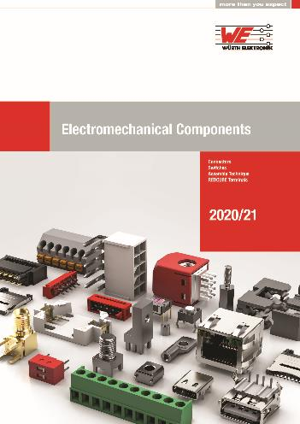
Image source: Würth Elektronik
Electromechanical Components 2021 catalog

About the Würth Elektronik eiSos Group
Würth Elektronik eiSos Group is a manufacturer of electronic and electromechanical components for the electronics industry and a technology company that spearheads pioneering electronic solutions. Würth Elektronik eiSos is one of the largest European manufacturers of passive components and is active in 50 countries. Production sites in Europe, Asia and North America supply a growing number of customers worldwide.
The product range includes EMC components, inductors, transformers, RF components, varistors, capacitors, resistors, quartz crystals, oscillators, power modules, Wireless Power Transfer, LEDs, sensors, connectors, power supply elements, switches, push-buttons, connection technology, fuse holders and solutions for wireless data transmission.
The unrivaled service orientation of the company is characterized by the availability of all catalog components from stock without minimum order quantity, free samples and extensive support through technical sales staff and selection tools.
Through its technology partnership with the Audi Sport ABT Schaeffler Formula E Team and its support for the Formula Student racing series, the company demonstrates its innovative strength in eMobility
(www.we-speed-up-the-future.com).
Würth Elektronik is part of the Würth Group, the world market leader for assembly and fastening technology. The company employs 7,300 staff and generated sales of 822 million euros in 2019.
Würth Elektronik: more than you expect!
Further information at www.we-online.com

Further information:  Würth Elektronik eiSos GmbH & Co. KG  Sarah Hurst  Max-Eyth-Strasse 1  74638 Waldenburg  Germany  Phone: +49 7942 945-5186  E-mail: sarah.hurst@we-online.de  www.we-online.de | Press contact:  HighTech communications GmbH  Brigitte Basilio  Brunhamstrasse 21  81249 Munich  Germany  Phone: +49 89 500778-20  Telefax: +49 89 500778-77  E-mail: b.basilio@htcm.de  www.htcm.de

