PRESS RELEASE
IQD launches new variable supply voltage oscillator
Waldenburg (Germany), 27 October 2020 – IQD Frequency Products is pleased to launch its newest standard packaged clock oscillator series, the IQXO 951, which operates with a supply voltage range from 1.6 V to 3.3 V. Many of today’s industrial and consumer applications require batteries as power source. Therefore, products need to handle a change in voltage as the battery discharges. This can lead to design issues when using a standard oscillator with a fixed supply voltage. A discharging battery may cause a decrease in the source voltage, which consequently change the frequency of the oscillator. Following this, the timing accuracy within the application will decline.
The IQXO-951 is available in industry standard packages of 3.2 x 2.5 mm, 2.5 x 2.0 mm and 2.0 x 1.6 mm. It will allow electronic equipment manufacturers to benefit from standard stability of ± 25 ppm over the industrial temperature range from -40 to 85 degrees C. Moreover, parts are also available with extended temperature range up to -40 to 125 degrees C.
The new clock oscillators are suitable for most applications that are designed for battery-powered products. In addition, customers could reduce their BOM management by using a single part instead of multiple oscillators with fixed supply voltages. Common markets for these applications are Telecommunications, IoT, Communication, medical and many others.
Full details on the IQXO-951 are available at www.iqdfrequencyproducts.com or for further advice, speak to a member of our Sales team or Application Support team.

Available images
The following images can be downloaded from the Internet in printable quality: http://www.htcm.de/kk/wuerth

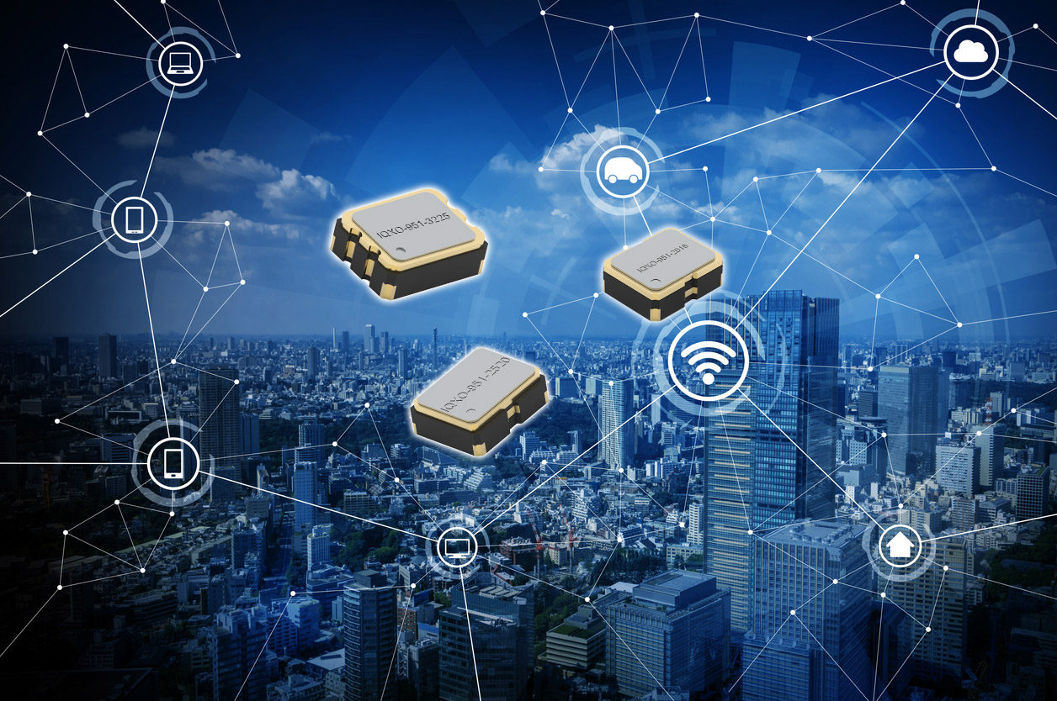
Image source: IQD
Clock oscillators of the IQXO-951 series in standard package (SPXO)

About IQD
Backed by over 40 years’ experience in the manufacture of frequency products, IQD is a recognised market leader in the frequency control market and part of the Würth Elektronik eiSos group, one of the leading European manufacturers of passive components. With active customers in over 80 countries, IQD offers one of the most comprehensive frequency product ranges available, from low cost commercial grade product to that used in high reliability industrial and automotive applications including: Quartz Crystals, Clock Oscillators, AEC-Q200 Crystals & Oscillators, VCXOs, TCXOs, OCVCSOs & OCXOs, GPS Disciplined OCXOs, and Rubidium Oscillators.
Further info at www.iqdfrequencyproducts.com

About the Würth Elektronik eiSos Group
Würth Elektronik eiSos Group is a manufacturer of electronic and electromechanical components for the electronics industry and a technology company that spearheads pioneering electronic solutions. Würth Elektronik eiSos is one of the largest European manufacturers of passive components and is active in 50 countries. Production sites in Europe, Asia and North America supply a growing number of customers worldwide.
The product range includes EMC components, inductors, transformers, RF components, varistors, capacitors, resistors, quartz crystals, oscillators, power modules, Wireless Power Transfer, LEDs, sensors, connectors, power supply elements, switches, push-buttons, connection technology, fuse holders and solutions for wireless data transmission.

The unrivaled service orientation of the company is characterized by the availability of all catalog components from stock without minimum order quantity, free samples and extensive support through technical sales staff and selection tools.
Through its technology partnership with the Audi Sport ABT Schaeffler Formula E Team and its support for the Formula Student racing series, the company demonstrates its innovative strength in eMobility
(www.we-speed-up-the-future.com).
Würth Elektronik is part of the Würth Group, the world market leader for assembly and fastening technology. The company employs 7,300 staff and generated sales of 822 million euros in 2019.
Würth Elektronik: more than you expect!
Further information at www.we-online.com

Further information:  IQD Frequency Products Ltd  Rebecca Long  Station Road  Crewkerne  Somerset  TA18 8AR  United Kingdom  Phone: +44 1460 270270  E-mail: rebecca.long@iqdfrequencyproducts.com  www.we-online.com  www.iqdfrequencyproducts.com | Press contact:  HighTech communications GmbH  Brigitte Basilio  Brunhamstrasse 21  81249 Munich  Germany  Phone: +49 89 500778-20  Telefax: +49 89 500778-77  E-mail:  b.basilio@htcm.de  www.htcm.de

