PRESS RELEASE
Würth Elektronik on the European Week for Waste Reduction
Switching to More Sustainable Packaging
Waldenburg (Germany), 26 November 2020—Logistics at one of Europe’s biggest manufacturers of electronic and electromechanical components has declared war on packaging waste. Würth Elektronik is putting all goods packaging processes to the test. The internal goals: drastic reduction of plastics and a switch to more sustainable materials.
Many waste-reducing measures have already been realized or are being implemented: For example, Würth Elektronik's Logistics only uses filling material based on recycled paper and also minimizes consumption by using hold-down devices and separating boxes. Padded envelopes are plastic-free, paper-based parcel tape holds parcels together where necessary, and boxes with lids save on adhesive tape. Plastic bags are being replaced by parchment paper bags on a large scale, for example for the delivery documents on the outside of parcels.
On the occasion of the European Week for Waste Reduction (Nov. 21-29, 2020) says Georgios Stamos, Head of Logistics in Waldenburg, Environmental Officer in Logistics at Würth Elektronik eiSos: "According to the German Federal Environment Agency, per capita packaging consumption has increased by 17.9 percent since 2010. Of this, more than half is caused by industry and commerce. So we are looking closely where we can become more sustainable. We are currently evaluating cardboard boxes that consist of up to 50 percent grass. In doing so, we are facing up to special requirements: Because we, as a developer service provider, offer free samples and design kits with replenishment, and this makes for a large number of small shipments. This service should be maintained, of course, but will be provided more sustainably in the future. Both here and elsewhere, protecting our environment involves a multitude of coordinated steps, which come with costs for the company. But the reduction of packaging waste is a responsibility that we as the workforce and company are happy to accept with great commitment.”

Available images
The following images can be downloaded from the Internet in printable quality: http://www.htcm.de/kk/wuerth

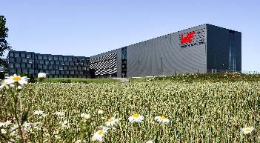  Image source: Würth Elektronik  Würth Elektronik eiSos Technology Center in Waldenburg | 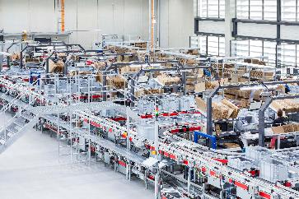  Image source: Würth Elektronik  Drastic reduction of plastics and a switch to more sustainable materials at Würth Elektronik

About the Würth Elektronik eiSos Group
Würth Elektronik eiSos Group is a manufacturer of electronic and electromechanical components for the electronics industry and a technology company that spearheads pioneering electronic solutions. Würth Elektronik eiSos is one of the largest European manufacturers of passive components and is active in 50 countries. Production sites in Europe, Asia and North America supply a growing number of customers worldwide.
The product range includes EMC components, inductors, transformers, RF components, varistors, capacitors, resistors, quartz crystals, oscillators, power modules, Wireless Power Transfer, LEDs, sensors, connectors, power supply elements, switches, push-buttons, connection technology, fuse holders and solutions for wireless data transmission.
The unrivaled service orientation of the company is characterized by the availability of all catalog components from stock without minimum order quantity, free samples and extensive support through technical sales staff and selection tools.
Through its technology partnership with the Audi Sport ABT Schaeffler Formula E Team and its support for the Formula Student racing series, the company demonstrates its innovative strength in eMobility
(www.we-speed-up-the-future.com).
Würth Elektronik is part of the Würth Group, the world market leader for assembly and fastening technology. The company employs 7,300 staff and generated sales of 822 million euros in 2019.
Würth Elektronik: more than you expect!
Further information at www.we-online.com

Further information:  Würth Elektronik eiSos GmbH & Co. KG  Sarah Hurst  Max-Eyth-Strasse 1  74638 Waldenburg  Germany  Phone: +49 7942 945-5186  E-mail: sarah.hurst@we-online.de  www.we-online.de | Press contact:  HighTech communications GmbH  Brigitte Basilio  Brunhamstrasse 21  81249 Munich  Germany  Phone: +49 89 500778-20  Telefax: +49 89 500778-77  E-mail: b.basilio@htcm.de  www.htcm.de

