PRESS RELEASE
Würth Elektronik: Virtual Conference "WE meet @ digital days 2020"
Virtual expert forum
Waldenburg (Germany), 17 November 2020 – From 1st to 3rd of December (each from 8 am to 6 pm) Würth Elektronik organizes the virtual conference "WE meet @ digital days 2020" with an extensive program of various technical presentations. The virtual conference offers technical and technology presentations on applications and design-in support - all with an interactive question-and-answer part. In addition, experts from the component manufacturer will be presenting many new products from the Passive & Electromechanical Components, Power Modules & Optoelectronics, Automotive, Frequency Products and Wireless Connectivity & Sensors divisions in English live presentations. Those interested can find the program and free registration for the three-day online forum at www.we-online.com/digital-days. The sessions can be attended individually.
The technological development of components and electronic designs continues to progress rapidly even in the pandemic. In order to keep customers and interested parties up to date, Würth Elektronik is actively establishing new information channels and is shifting the contact possibilities familiar from trade fairs and events to the online world. In response to the Corona-related cancellations of important trade shows, Würth Elektronik has also set up a virtual booth on its website, which will also be part of the conference.
For "WE meet @ digital days 2020" the developers and experts at Würth Elektronik have covered a wide range of topics. There will be lectures on thermal simulation and calculation for power modules in REDEXPERT, on ranges and characteristics of coaxial cabling, on EMC filtering in automotive electronics or on design effects of the reduction of quartz crystals. It is about Single Pair Ethernet and ribbon cables as well as cable ferrites, capacitors, gate driver circuits or electromechanical board connections, LEDs in horticultural applications or EMC troubleshooting. In individual lectures of the expert forum, the speakers can be contacted directly via chat functions in order to clarify questions and comments immediately in the online dialog. The experts will also be available for individual consultation after the event. In addition, all lectures are available as recordings on the website.
Interested parties can view the extensive lecture program at www.we-online.com/digital-days and register for the individual topics of the online event "WE meet @ digital days 2020".

Available images
The following images can be downloaded from the Internet in printable quality: http://www.htcm.de/kk/wuerth
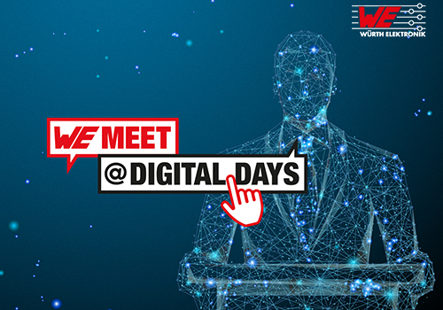Source: Würth Elektronik
The Virtual Conference "WE meet @ digital days 2020" will take place from 1st to 3rd December 2020.

About the Würth Elektronik eiSos Group
Würth Elektronik eiSos Group is a manufacturer of electronic and electromechanical components for the electronics industry and a technology company that spearheads pioneering electronic solutions. Würth Elektronik eiSos is one of the largest European manufacturers of passive components and is active in 50 countries. Production sites in Europe, Asia and North America supply a growing number of customers worldwide.
The product range includes EMC components, inductors, transformers, RF components, varistors, capacitors, resistors, quartz crystals, oscillators, power modules, Wireless Power Transfer, LEDs, sensors, connectors, power supply elements, switches, push-buttons, connection technology, fuse holders and solutions for wireless data transmission.
The unrivaled service orientation of the company is characterized by the availability of all catalog components from stock without minimum order quantity, free samples and extensive support through technical sales staff and selection tools.
Through its technology partnership with the Audi Sport ABT Schaeffler Formula E Team and its support for the Formula Student racing series, the company demonstrates its innovative strength in eMobility
(www.we-speed-up-the-future.com).
Würth Elektronik is part of the Würth Group, the world market leader for assembly and fastening technology. The company employs 7,300 staff and generated sales of 822 million euros in 2019.
Würth Elektronik: more than you expect!
Further information at www.we-online.com

Further information:  Würth Elektronik eiSos GmbH & Co. KG  Sarah Hurst  Max-Eyth-Strasse 1  74638 Waldenburg  Germany  Phone: +49 7942 945-5186  E-mail: sarah.hurst@we-online.de  www.we-online.de | Press contact:  HighTech communications GmbH  Brigitte Basilio  Brunhamstrasse 21  81249 Munich  Germany  Phone: +49 89 500778-20  Telefax: +49 89 500778-77  E-mail: b.basilio@htcm.de  www.htcm.de

