PRESS RELEASE
Würth Elektronik organized "WE meet @ digital days 2020"
Three-day virtual conference with valuable know-how and enthusiastic participants
Waldenburg (Germany), 11 December 2020 – Würth Elektronik organized the "WE meet @ digital days 2020" from December 1st to 3rd, starting from 8:00 to 18:00 o'clock per day. A total of 30 digital live presentations took place, hosted by Würth Elektronik experts for electronic & electromechanical components. The hosts shared insights into current challenges and trends in electronics design as well as information on new solutions and components. With more than 2,300 participants, the virtual conference proved to be a successful way of staying in touch digitally with customers, interested parties and developers from a wide range of industries. Questions were answered live via a chat function or subsequently by e-mail. All presentations of the event can be listened to and viewed at www.we-online.com/digital-days.
The international composition of the participants at Würth Elektronik's event showed how much the new forms of communication and meetings with their efficiency are appreciated: More than 2,300 participants from almost all regions of the world - from Europe, the USA, India, China, other Asian countries, Africa, the Middle East and other regions - were selected. The presentations from the divisions Passive & Electromechanical Components, Power Modules & Optoelectronics, Automotive, Frequency Products as well as Wireless Connectivity & Sensors clearly showed the speakers' enthusiasm for their respective fields: One participant described the contributions of the experts, some of whom were connected from their home offices, as "very personal video conferences with people who know their way around". Many developers used the chat function to get answers to specific questions from current projects. Among the conference visitors' favorites by number of participants were the topics "How cable and PCB ferrites can help to avoid EMC problems", "EMC filters - from component to design" or "Board level shielding and the treatment of common mode interference in new high frequency technologies".
Very positive summary
Thomas Schrott, CEO of the Würth Elektronik eiSos Group, is impressed by the event: "These times bring many challenges - the loss of personal contacts at trade fairs is one of them. The virtual conference is a way to communicate innovations and thus open up new design possibilities for developers".
"Consulting and design-in support are part of our service. The technical presentations showed how great the interest is in the electronics market", says Alexander Gerfer, CTO at the Würth Elektronik eiSos Group, and Thomas Wild, CFO at the Würth Elektronik eiSos Group, adds: "The reactions showed how important know-how transfer is and how the topics hit the nerve of many developers. My thanks go to the team that selected the topics and organized the digital conference".

Available images
The following images can be downloaded from the Internet in printable quality: http://www.htcm.de/kk/wuerth
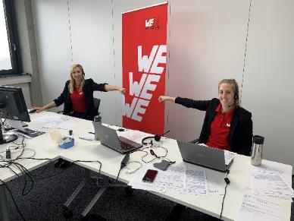Image source: Würth Elektronik  Successful virtual conference "WE meet @ digital days": Discussions with customers and interested parties via digital channels. On the picture Lisa Richter (left) and Marie-Theres Kohl from the organization team (both Würth Elektronik eiSos) | 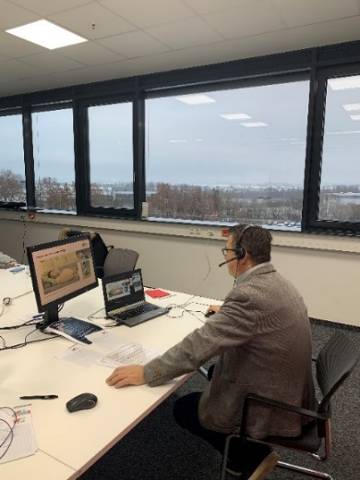Image source: Würth Elektronik  Lorandt Fölkel, Global Business Consultant at Würth Elektronik eiSos, answered questions on the chat.

About the Würth Elektronik eiSos Group
Würth Elektronik eiSos Group is a manufacturer of electronic and electromechanical components for the electronics industry and a technology company that spearheads pioneering electronic solutions. Würth Elektronik eiSos is one of the largest European manufacturers of passive components and is active in 50 countries. Production sites in Europe, Asia and North America supply a growing number of customers worldwide.
The product range includes EMC components, inductors, transformers, RF components, varistors, capacitors, resistors, quartz crystals, oscillators, power modules, Wireless Power Transfer, LEDs, sensors, connectors, power supply elements, switches, push-buttons, connection technology, fuse holders and solutions for wireless data transmission.
The unrivaled service orientation of the company is characterized by the availability of all catalog components from stock without minimum order quantity, free samples and extensive support through technical sales staff and selection tools.
Through its technology partnership with the Audi Sport ABT Schaeffler Formula E Team and its support for the Formula Student racing series, the company demonstrates its innovative strength in eMobility
(www.we-speed-up-the-future.com).
Würth Elektronik is part of the Würth Group, the world market leader for assembly and fastening technology. The company employs 7,300 staff and generated sales of 822 million euros in 2019.
Würth Elektronik: more than you expect!
Further information at www.we-online.com

Further information:  Würth Elektronik eiSos GmbH & Co. KG  Sarah Hurst  Max-Eyth-Strasse 1  74638 Waldenburg  Germany  Phone: +49 7942 945-5186  E-mail: sarah.hurst@we-online.de  www.we-online.de | Press contact:  HighTech communications GmbH  Brigitte Basilio  Brunhamstrasse 21  81249 Munich  Germany  Phone: +49 89 500778-20  Telefax: +49 89 500778-77  E-mail: b.basilio@htcm.de  www.htcm.de

