PRESS RELEASE
Würth Elektronik at electronica China 2021
One of world’s smallest wound chokes, high-current PCB contacts, horticultural LEDs, and a greenhouse
Shanghai (China), 1 April 2021 - Würth Elektronik, a premium German manufacturer of electronic and electromechanical components, will be exhibiting at electronica China (14-16 April 2021, Shanghai New International Expo Center, booth N1.1309). Highlights of the company’s exhibits include a greenhouse demonstration on the booth, where the manufacturer will showcase its expertise in the field of horticulture LEDs, plus WE-MAPI, a series of wound metal-alloy storage chokes that are arguably the world's smallest. Other focal points are components for Single Pair Ethernet, the innovative REDCUBE high-current PCB contacts and REDEXPERT, a service for developers comprising a free online tool with functionality that precisely calculates AC losses and for simulating the inductance for selection in DC/DC switching regulators.
For Würth Elektronik, electronica China is not only an event to present innovative products, but also an opportunity to share knowledge. On 14 April (1pm-5pm, room N1-M40), the company will invite developers to a technical seminar focused on important topics such as the simulation of current components, the assessment of losses, a variety of high-frequency transformer applications, and the analysis of EMC solutions. Further seminar topics comprise WE REDEXPERT Applications, AC loss simulation and verification, REDCUBE contact technology and its applications, and deploying ferrite in EMC control applications.
In collaboration with universities and agricultural scientists, the optoelectronics experts at Würth Elektronik have researched the influence of light frequencies on plant growth. Now the company can offer the optimum LED products as well as circuit designs for LED control to create light formulations as “light recipes”. A small greenhouse on the exhibition booth highlights this forward-looking, rapidly growing field of LED applications. The demonstration deploys the reference design of Analog Devices LT3966, an intelligent 60V monolithic LED driver, along with WE-MAPI, WCAP-ASLL and WCAP-CSGP products.
Highest efficiency, highest temperatures
WE-MAPI are among the smallest wound metal-alloy storage chokes in the world. They are characterized by high saturation current, high permeability and low resistance. The most important application area for WE-MAPI is in DC/DC switching regulators featuring high power and high efficiency for switching frequencies up to 20MHz. The new star of the series will be presented in Shanghai: With an operating temperature range of -55 to +150°C, the WE-MAPI 4020HT choke is unique and delivers 55 per cent lower AC winding losses than comparable products on the market.
Single Pair Ethernet goes industrial
As a member of the SPE Industrial Partner Network initiative, Würth Elektronik promotes the use of Single Pair Ethernet in industrial applications. At electronica, Würth Elektronik is presenting a circuit layout that deploys transformers as galvanic isolation to enable safe use in industrial applications. The solution features an isolation of 1.5kV/60s and is therefore perfectly suited to industrial use, in contrast to previous circuits that use two 50V capacitors as galvanic isolation.
Reliable contact: REDCUBE
Reliable PCB contacts are vital to prevent self-heating in high-current applications. A highly reliable "Made in Germany" solution are REDCUBE terminals from Würth Elektronik. Featuring press-fit technology, these contacts milled from brass form effective vibration-resistant connections with low electrical resistance.
Chinese developers can now also find information about Würth Elektronik's new products at www.21ic.com and on the company’s WEChat channel.

Available images
The following images can be downloaded from the Internet in printable quality: http://www.htcm.de/kk/wuerth
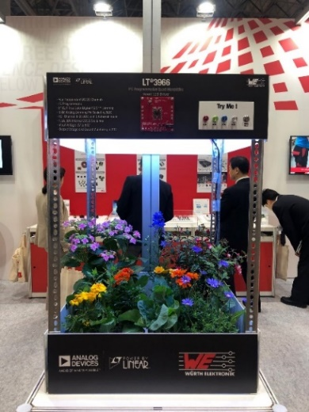  Image source: Würth Elektronik  The component manufacturer as researcher: together with ADI, Würth Elektronik is investigating how plant growth can be influenced with light recipes. | 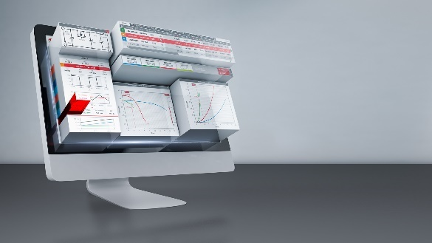  Image source: Würth Elektronik  Selecting components on the basis of real measurements using the free online tool – the RedExpert online platform.

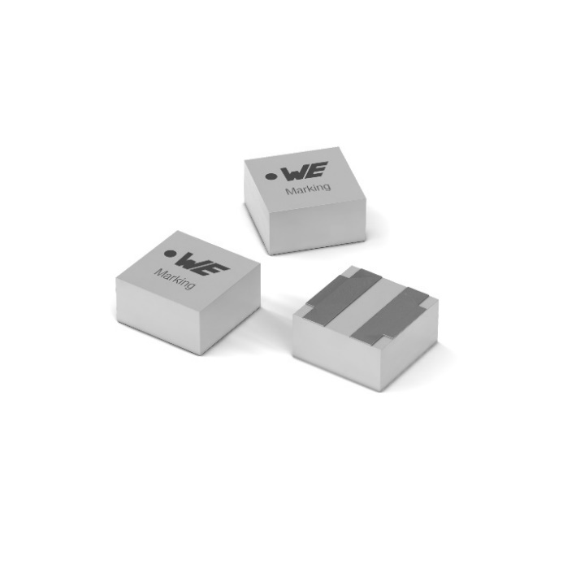
Image source: Würth Elektronik
The WE-MAPI is one of the world’s smallest metal alloy power inductors.

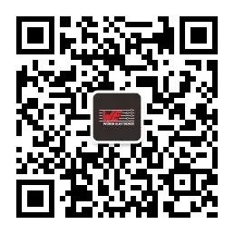  Image source: Würth Elektronik  QR-Code to the WeChat Channel of Würth Elektronik | 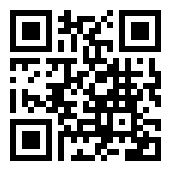  Image source: Würth Elektronik  QR-Code to the WE 21IC Microsite

About the Würth Elektronik eiSos Group
Würth Elektronik eiSos Group is a manufacturer of electronic and electromechanical components for the electronics industry and a technology company that spearheads pioneering electronic solutions. Würth Elektronik eiSos is one of the largest European manufacturers of passive components and is active in 50 countries. Production sites in Europe, Asia and North America supply a growing number of customers worldwide.
The product range includes EMC components, inductors, transformers, RF components, varistors, capacitors, resistors, quartz crystals, oscillators, power modules, Wireless Power Transfer, LEDs, sensors, connectors, power supply elements, switches, push-buttons, connection technology, fuse holders and solutions for wireless data transmission.
The unrivaled service orientation of the company is characterized by the availability of all catalog components from stock without minimum order quantity, free samples and extensive support through technical sales staff and selection tools.
Through its technology partnership with the Audi Sport ABT Schaeffler Formula E Team and its support for the Formula Student racing series, the company demonstrates its innovative strength in eMobility
(www.we-speed-up-the-future.com).
Würth Elektronik is part of the Würth Group, the world market leader for assembly and fastening technology. The company employs 7,300 staff and generated sales of 823 million euros in 2020.
Würth Elektronik: more than you expect!
Further information at www.we-online.com

Further information:  Würth Elektronik eiSos GmbH & Co. KG  Sarah Hurst  Max-Eyth-Strasse 1  74638 Waldenburg  Germany  Phone: +49 7942 945-5186  E-mail: sarah.hurst@we-online.de  www.we-online.de | Press contact:  HighTech communications GmbH  Brigitte Basilio  Brunhamstrasse 21  81249 Munich  Germany  Phone: +49 89 500778-20  Telefax: +49 89 500778-77  E-mail: b.basilio@htcm.de  www.htcm.de

