PRESS RELEASE

Würth Elektronik's virtual conference WE meet @ digital days 2021
Four days of concentrated electronics knowledge for developers
Waldenburg (Germany), March 31, 2021 – In 2021, Würth Elektronik will again be holding its virtual trade conference WE meet @ digital days - this time over four days from April 26 to 29. From 8:00 a.m. to 6:00 p.m. each day, electronics specialist will present an extensive program with expert presentations on EMC, power & thermal management, wireless power and many other circuit design topics. The English-language lectures will be followed by interactive question and answer sessions for more in-depth coverage. In addition, Würth Elektronik specialists will present the latest developments from the areas of Passive & Electromechanical Components, Power Modules & Optoelectronics, Automotive, Frequency Products as well as Wireless Connectivity & Sensors and Custom Magnetics. Full information on the program, which is free to visitors, and registration can be found at www.we-online.com/digital-days.
"The Corona crisis was a catalyst in digitalization for many. We, too, have further developed our claim of being a service leader with new offerings, and our first virtual conference in December 2020 was a great success. This was one of the reasons why we are offering the event again this year and extending it by a whole day to boot," explains Alexander Gerfer, CTO of the Würth Elektronik eiSos Group. "This allows us to offer our visitors an even broader spectrum with even greater depth - also through contributions from our partners."
Know-how on EMC from Würth Elektronik
The new EMI filter designer in the REDEXPERT simulation software is an example of tools for optimizing electronic assemblies. With their high level of EMC expertise, experts from Würth Elektronik provide valuable insights and suggestions for avoiding errors in the design of circuits at an early stage.
"more than you expect!" - Motto and program
With WE meet @ digital days, Würth Elektronik offers developers a unique opportunity to obtain condensed information about the current state of technology and future developments. In addition, visitors benefit for their daily work through practical tips, background information and application examples from a wide range of specialist areas. The event will start on April 26 at 8:00 a.m. with a keynote by Alexander Gerfer, CTO of the Würth Elektronik eiSos Group. The online seminars will be held by experts from the Passive & Electromechanical Components, Power Modules & Optoelectronics, Automotive, Frequency Products as well as Wireless Connectivity & Sensors and Custom Magnetics product divisions at Würth Elektronik.
The length of the technical presentations is about 30 minutes each. A chat function enables direct contact with the Würth Elektronik specialists. Accompanying the virtual conference, a virtual booth can be visited, where current product catalogs, product presentations and other information material are available. Shortly after the events, video recordings of the presentations will be available for download.
Formula E technology partnership
On Tuesday, April 27, at 2:00 p.m., the program invites motorsport enthusiasts to an interview and Q&A session with Lucas DiGrassi and René Rast from the Formula E team Audi Sport ABT Schaeffler, with whom Würth Elektronik has a technology partnership.
Registration now possible
Registration for the free virtual conference WE meet @ digital days is now open. All presentations can be booked individually.
Information on the lecture program with the individual topics and registration for registration are available centrally at www.we-online.com/digital-days.

Available images
The following images can be downloaded from the Internet in printable quality: http://www.htcm.de/kk/wuerth
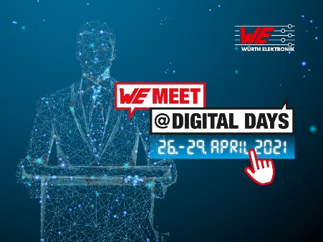  Image source: Würth Elektronik  WE meet @ digital days from 26 to 29 April 2021 - four days of concentrated know-how from electronics specialist Würth Elektronik | 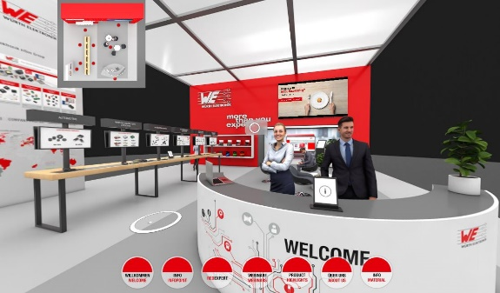 Image source: Würth Elektronik  The virtual booth offers accompanying product catalogs, product presentations and other information material.

About the Würth Elektronik eiSos Group
Würth Elektronik eiSos Group is a manufacturer of electronic and electromechanical components for the electronics industry and a technology company that spearheads pioneering electronic solutions. Würth Elektronik eiSos is one of the largest European manufacturers of passive components and is active in 50 countries. Production sites in Europe, Asia and North America supply a growing number of customers worldwide.
The product range includes EMC components, inductors, transformers, RF components, varistors, capacitors, resistors, quartz crystals, oscillators, power modules, Wireless Power Transfer, LEDs, sensors, connectors, power supply elements, switches, push-buttons, connection technology, fuse holders and solutions for wireless data transmission.
The unrivaled service orientation of the company is characterized by the availability of all catalog components from stock without minimum order quantity, free samples and extensive support through technical sales staff and selection tools.
Through its technology partnership with the Audi Sport ABT Schaeffler Formula E Team and its support for the Formula Student racing series, the company demonstrates its innovative strength in eMobility
(www.we-speed-up-the-future.com).
Würth Elektronik is part of the Würth Group, the world market leader for assembly and fastening technology. The company employs 7,300 staff and generated sales of 823 million euros in 2020.
Würth Elektronik: more than you expect!
Further information at www.we-online.com

Further information:  Würth Elektronik eiSos GmbH & Co. KG  Sarah Hurst  Max-Eyth-Strasse 1  74638 Waldenburg  Germany  Phone: +49 7942 945-5186  E-mail: sarah.hurst@we-online.de  www.we-online.de | Press contact:  HighTech communications GmbH  Brigitte Basilio  Brunhamstrasse 21  81249 Munich  Germany  Phone: +49 89 500778-20  Telefax: +49 89 500778-77  E-mail: b.basilio@htcm.de  www.htcm.de

