PRESS RELEASE

Updates on IQD’s IQRB-3 rubidium oscillator available
IQRB-3: low noise rubidium oscillator with 1 PPS input/output
Waldenburg (Germany), 12 April 2021 – IQD Frequency Products, a subsidiary of the Würth Elektronik eiSos Group, is currently focusing its engineering expertise on providing best-in-class rubidium atomic clock oscillators. Following the recent releases of new products in this portfolio, the ICPT-1 and the IQRB-4, and an extensive update on the IQRB-1, IQD is now able to share new data on the IQRB-3.
The IQRB-3 can be synchronised to a 1 PPS signal as well as used as a 1 PPS source. Additionally, it offers superb phase noise performance with a close in phase noise typically at -110 dBc/Hz @ 1 Hz and a noise floor as low as -158 dBc/Hz. Furthermore, it combines tight tolerance and ±0.3 ppb temperature stability (-20 to 60 °C) with great short term and long term stability. This makes the IQRB-3 the ideal fit for timing applications that require a very precise frequency.
As with all our high-end products, we recognize that measurements given on the datasheet are specific to the test setup and environment, that’s why we have compiled a handbook documenting the precise details for each line on the datasheet. If these don’t match your environment, we are happy to adapt and repeat our measurements as per your requirements.
Further information on the IQRB-3 or IQD's rubidium portfolio is available on the IQD website at www.iqdfrequencyproducts.com.
The new IQRB-3 handbook can be obtained from the IQD sales office.

Available images
The following images can be downloaded from the Internet in printable quality: http://www.htcm.de/kk/wuerth

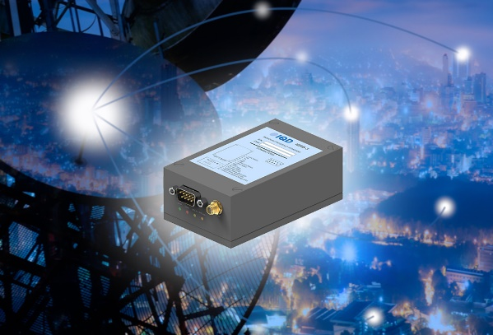
Image source: IQD
IQRB-3, IQD's rubidium oscillator

About IQD
Backed by over 40 years’ experience in the manufacture of frequency products, IQD is a recognised market leader in the frequency control market and part of the Würth Elektronik eiSos Group, one of the leading European manufacturers of passive components. With active customers in over 80 countries, IQD offers one of the most comprehensive frequency product ranges available, from low cost commercial grade product to that used in high reliability industrial and automotive applications including: Quartz Crystals, Clock Oscillators, AEC-Q200 Crystals & Oscillators, VCXOs, TCXOs, OCVCSOs & OCXOs, GPS Disciplined OCXOs, and Rubidium Oscillators.
Further info at www.iqdfrequencyproducts.com

About the Würth Elektronik eiSos Group
Würth Elektronik eiSos Group is a manufacturer of electronic and electromechanical components for the electronics industry and a technology company that spearheads pioneering electronic solutions. Würth Elektronik eiSos is one of the largest European manufacturers of passive components and is active in 50 countries. Production sites in Europe, Asia and North America supply a growing number of customers worldwide.
The product range includes EMC components, inductors, transformers, RF components, varistors, capacitors, resistors, quartz crystals, oscillators, power modules, Wireless Power Transfer, LEDs, sensors, connectors, power supply elements, switches, push-buttons, connection technology, fuse holders and solutions for wireless data transmission.
The unrivaled service orientation of the company is characterized by the availability of all catalog components from stock without minimum order quantity, free samples and extensive support through technical sales staff and selection tools.
Through its technology partnership with the Audi Sport ABT Schaeffler Formula E Team and its support for the Formula Student racing series, the company demonstrates its innovative strength in eMobility
(www.we-speed-up-the-future.com).
Würth Elektronik is part of the Würth Group, the world market leader for assembly and fastening technology. The company employs 7,300 staff and generated sales of 823 million euros in 2020.
Würth Elektronik: more than you expect!
Further information at www.we-online.com

Further information:  IQD Frequency Products Ltd  Rebecca Long  Station Road  Crewkerne  Somerset  TA18 8AR  United Kingdom  Phone: +44 1460 270270  E-mail: rebecca.long@iqdfrequencyproducts.com  www.we-online.com  www.iqdfrequencyproducts.com | Press contact:  HighTech communications GmbH  Brigitte Basilio  Brunhamstrasse 21  81249 Munich  Germany  Phone: +49 89 500778-20  Telefax: +49 89 500778-77  E-mail:  b.basilio@htcm.de  www.htcm.de

