PRESS RELEASE

Commitment to transport system research
Würth Elektronik Proud to be Partner of European Hyperloop Week in July in Valencia
Waldenburg (Germany), May 11, 2021 - Würth Elektronik will support the first European Hyperloop Week as an exclusive partner. From July 19 to 25, 2021, a conference filled with round table discussions, keynotes, and the presentation of vehicles called "pods" will take place in Valencia. The highlight of the event will be the pod competition. Representatives from the manufacturer of electronic and electromechanical components will also present. Leading up to the main event, a major contribution is already occurring Würth Elektronik is sponsoring three Hyperloop teams, supplying components and carrying out the thermal and EMC testing in joint laboratories, which are available at the University of Valencia as part of the long-standing research cooperation with Fundación Catédra.
Unveiled by Elon Musk in 2014, the progress of the Hyperloop mobility concept with capsules in evacuated tubes, has been presented mainly at the SpaceX site in Los Angeles County in California, USA. For the first time, Hyperloop Week is coming to Europe. The four Hyperloop teams, HYPED from the University of Edinburgh, Swissloop ETH Zurich, Hyperloop UPV Valencia, and Delft Hyperloop, will host the event. The latter of the three have been supported by Würth Elektronik with components and technical support for years.
"We are looking forward to the conference and the pod competition. Hyperloop is an interesting future topic and we are proud to be able to support it with our know-how as a technology enabler, for example in the field of power electronics," says Jorge Victoria, Senior Product Manager EMC Shielding & Thermal Materials at Würth Elektronik eiSos.
Alexander Gerfer, CTO of the Würth Elektronik eiSos Group, will give a keynote at Hyperloop Week and says of the commitment to the student teams, "We support the pioneering spirit and innovative ideas of the next generation of engineers with our practical experience and know-how. Following the phrase 'Start-up meets Grown-up', it is often this combination that leads to good success in the market. Whether with our components or our know-how, we provide support when it comes to design. We want to give student development teams and the next generation of engineers a good start and thus promote innovation and pioneering spirit."

Available images
The following images can be downloaded from the Internet in printable quality: http://www.htcm.de/kk/wuerth
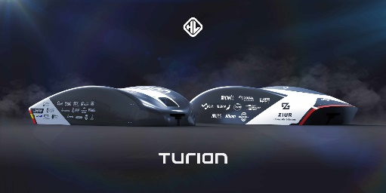
Image source: UPV (Universidad Politècnica de València)
Turian is the name of the Hyperloop UPV prototype

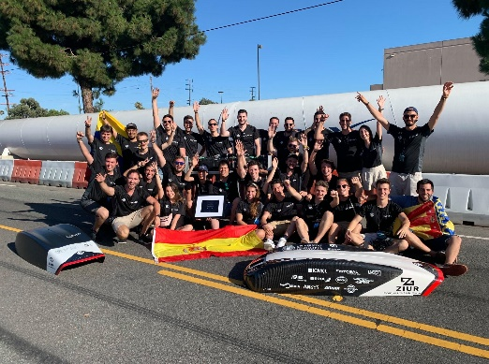Image source: UPV (Universidad Politècnica de València)  Image from Hyperloop Week, held at the SpaceX site in Los Angeles County in 2019 | 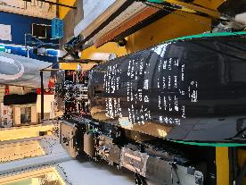  Image source: Hyperloop Delft  The Hyperloop Delft, pod from 2019

About the Würth Elektronik eiSos Group
Würth Elektronik eiSos Group is a manufacturer of electronic and electromechanical components for the electronics industry and a technology company that spearheads pioneering electronic solutions. Würth Elektronik eiSos is one of the largest European manufacturers of passive components and is active in 50 countries. Production sites in Europe, Asia and North America supply a growing number of customers worldwide.
The product range includes EMC components, inductors, transformers, RF components, varistors, capacitors, resistors, quartz crystals, oscillators, power modules, Wireless Power Transfer, LEDs, sensors, connectors, power supply elements, switches, push-buttons, connection technology, fuse holders and solutions for wireless data transmission.
The unrivaled service orientation of the company is characterized by the availability of all catalog components from stock without minimum order quantity, free samples and extensive support through technical sales staff and selection tools.
Through its technology partnership with the Audi Sport ABT Schaeffler Formula E Team and its support for the Formula Student racing series, the company demonstrates its innovative strength in eMobility
(www.we-speed-up-the-future.com).
Würth Elektronik is part of the Würth Group, the world market leader for assembly and fastening technology. The company employs 7,300 staff and generated sales of 823 million euros in 2020.
Würth Elektronik: more than you expect!
Further information at www.we-online.com

Further information:  Würth Elektronik eiSos GmbH & Co. KG  Sarah Hurst  Max-Eyth-Strasse 1  74638 Waldenburg  Germany  Phone: +49 7942 945-5186  E-mail: sarah.hurst@we-online.de  www.we-online.de | Press contact:  HighTech communications GmbH  Brigitte Basilio  Brunhamstrasse 21  81249 Munich  Germany  Phone: +49 89 500778-20  Telefax: +49 89 500778-77  E-mail: b.basilio@htcm.de  www.htcm.de

