PRESS RELEASE
Würth Elektronik ICS: REDline Power Box Hybrid for Dieci
Slimming Down Cable Harnesses
Niedernhall (Germany), 4 September 2018 – Italian manufacturer of machinery for material handling Dieci and Würth Elektronik ICS are expanding their partnership. For the past three years, Dieci has implemented the REDline Power Box Hybrid as a combined high-current fuse box, electrical distribution box, and CAN bus splitter. Now, two additional versions of the unit are going into series production. REDline Power Boxes are a platform concept developed by Würth Elektronik ICS for customer-specific power distribution solutions, which includes a standard box with a customer-specific circuit board with fuses and relays. With the help of these boxes, Dieci was able to considerably reduce the size of the cable harnesses of its telehandlers.
Two new versions of the REDline Power Box Hybrid are now going into series production for Dieci. The first box contains a Nano ICCS electronic relay that allows users to set individually programmed delay times in order to control ignition-activated loads. The second box is a classic relay and fuse box, characterized by its very high component density.
“Thanks to Würth Elektronik ICS, we have further developed our vehicle electrics into a more innovative version. We have only benefitted from this cooperation," praises Stefano Gabrini from Dieci’s Electrical Department. "The REDline Power Box Hybrid is used in all new Dieci vehicles and not only reduces the space required for power distribution, but also contributes to cost reductions by significantly reducing installation time."
Slimmer cable harnesses
The REDline Power Boxes from Würth Elektronik ICS offers individually configured power distribution, signal transmission and function control in a standard housing. Dieci is implementing three versions of the REDline Power Box Hybrid model. The 237.5 x 205.5 x 58 mm REDline Power Box Hybrid is specified for the temperature range -40 °C to +85 °C. The range for the fuses in the high current range (150 to 250 A) is designed according to protection class IP20. The IP54 sealed housing part contains the circuit board, which can be equipped with all available ICS sockets such as mini, ATO and maxi fuses and all common relay sockets up to high-current relay sockets. The main advantage for the Italian special vehicles manufacturer lies in the fact that the power distributor is separated from the main distribution board and can be installed close to the battery. The loads located near the battery benefit from direct switching and fuse protection.
"Dieci is the perfect reference customer for our REDline Power Boxes because they utilize the full potential of our solution. Robust standard housing units with an individual system solution for power distribution, signal transmission and control of vehicle functions that continue to function reliably under demanding thermal conditions. They have successfully streamlined the wiring harness and shortened the installation time. What more could you want?"

Available images
The following images can be downloaded from the Internet in printable quality: http://www.htcm.de/kk/wuerth_ics
Dieci implements different versions of the REDline Power Box Hybrid from Würth Elektronik ICS.
Image source: Würth Elektronik ICS
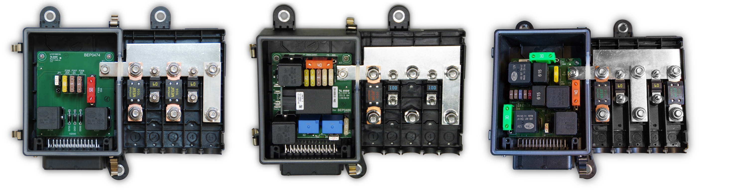

The cable harnesses on Dieci’s telehandlers could be significantly streamlined with the help of the REDline Power Box Hybrid from Würth Elektronik ICS.
Image source: Dieci

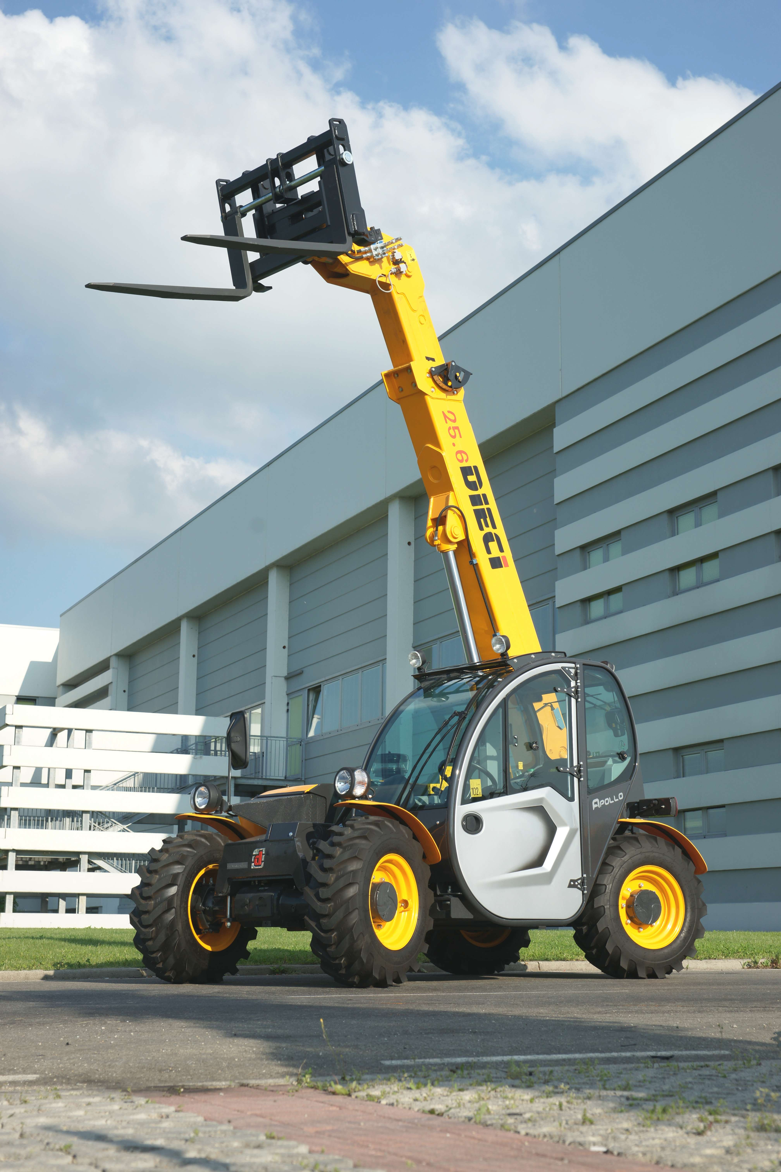

About Würth Elektronik ICS GmbH & Co. KG
Würth Elektronik ICS is a system supplier for electromechanical and electronic solutions for signal and power distribution, control, and display and operating solutions. ICS has been on the market as a member of the Würth Elektronik Group since 1984, and currently has about 350 employees, who generate an annual turnover of over €60 million. Its company headquarters are located in Niedernhall, Germany. There are subsidiaries of the company in France, the U.S., and India. Its main customers include well-known manufacturers of construction and agricultural machinery, as well as commercial vehicles. Sectors such as industrial technology, renewable energies, and shipbuilding also benefit from products and services provided by ICS.
Würth Elektronik: more than you expect!
Further info at www.we-online.com/ics

More information:  Würth Elektronik ICS GmbH & Co. KG  Sandra Herter  Gewerbepark Waldzimmern  Würthstrasse 1  74676 Niedernhall  Germany  Phone: +49 7940 9810-1503  E-mail: sandra.herter@we-online.de  www.we-online.com/ics | Press contact:  HighTech communications GmbH  Brigitte Basilio  Brunhamstrasse 21  81249 Munich  Germany  Phone: +49 89 500778-20  Telefax: +49 89 500778-77  E-mail: b.basilio@htcm.de  www.htcm.de

