PRESS RELEASE
Getriebebau NORD uses SKEDD technology by Würth Elektronik ICS
Simple, reversible and space-saving
Niedernhall (Germany), 11 September 2018 – Würth Elektronik ICS has created an optimal connecting solution for Getriebebau NORD – one of the leading manufacturers of drive technology – using SKEDD technology, and thus granted the company valuable freedom in component design.
Rear connection of the PCB within a limited assembly space was needed to produce the new NORD SK 250E motor starter and SK155E frequency inverter of the NORDAC LINK field distributor series. Applying the soldering method that had been used up to that point would have resulted in an additional socket base that would take up too much assembly space and necessitate an additional process step. However, the alternative option of using a separate PCB to connect the cables and connect them to the main circuit board using a board-to-board solution would have required a redesign of the entire product. After comprehensive research, the developer team at NORD decided to opt for SKEDD direct plug-in technology by Würth Elektronik ICS to avoid this considerably higher effort and find the most convenient solution possible. This enables direct connection from the rear side of the PCB as desired, without additional process steps.
SKW connector system as a solution
Together with the experts at ICS, Getriebebau NORD found the optimal solution by using the SKW connector. Its flexibility in terms of assembly design particularly convinced the customer: The SKW connector can generally be plugged in from either side, multiple times reversibly and all over the entire PCB surface. Due to this added value, it is used in the device versions of the NORDAC LINK field distributor, as NORD SK 155E-FDS motor starter and NORD SK 250E-FDS frequency inverter. In addition to the laborious soldering process, the extra base socket is no longer required.
More freedom for product designers
The SKW connectors also successfully passed system qualification, including a shock and vibration test according to IEC60721-3-3. The SKW connector system fully meets the requirements of NORD engineers at ambient temperatures in the range up to +70°C and currents up to 16 A.
“We are delighted to confirm that our SKEDD wire-to-board connector system has increased the level of freedom for product designers and has met all technical specifications,” says Achim Engel, Product Manager for SKEDD at Würth Elektronik ICS.
About SKW connector systems and SKEDD
SKW connector systems offer many advantages due to their direct, reversible plug-in capability, simple assembly and robustness, among other factors. As a straightforward and reliable alternative to soldering and press-fit technology, the patented SKEDD technology allows tool-free connection of components and connectors on PCBs for applications requiring currents of up to 20 A in two-pin, three-pin and four-pin design. The PCB is used as a socket, making a socket base unnecessary and reducing materials and interfaces.

Available images
The following images can be downloaded from the Internet in printable quality: http://www.htcm.de/kk/wuerth_ics
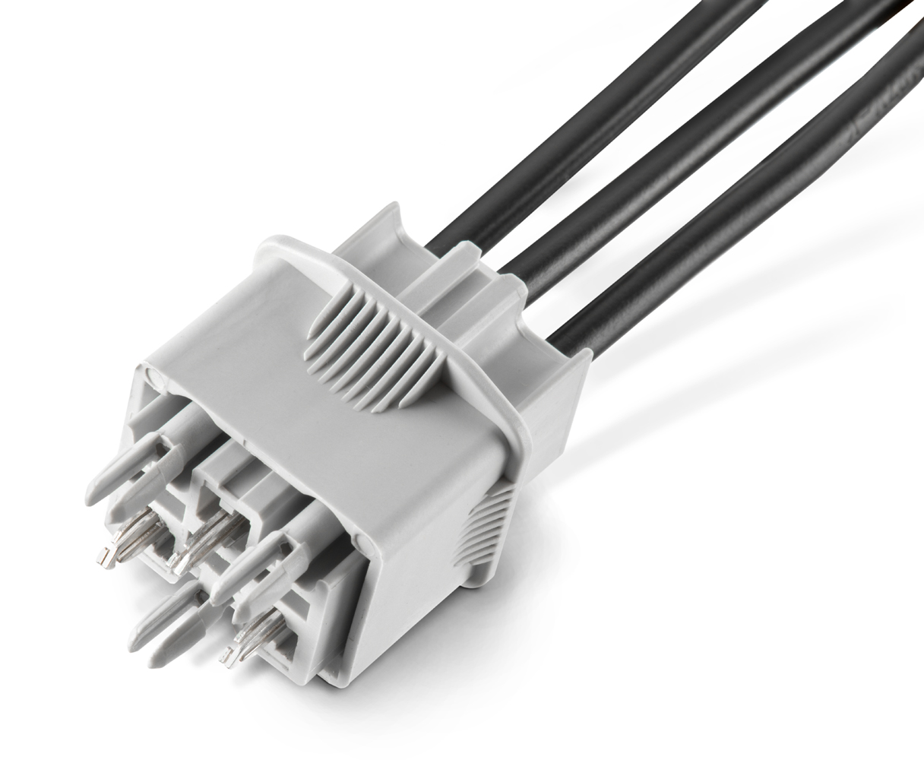  Image source: Würth Elektronik ICS  SKW connector in SKEDD technology by Würth Elektronik ICS | 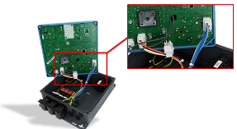  Image source: Würth Elektronik ICS  Opened NORDAC LINK SK 250E-FDS frequency inverter with SKW connectors (two-pin, four-pin), SKEDD K98104-AG contacts

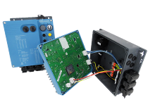  Image source: Würth Elektronik ICS  NORDAC LINK SK 155E-FDS motor starter, opened NORDAC LINK SK 155E-FDS motor starter with SKW connectors (two-pin, four-pin), SKEDD K98104-AG contacts | 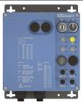  Image source: Würth Elektronik ICS  NORDAC LINK SK 155E-FDS motor starter

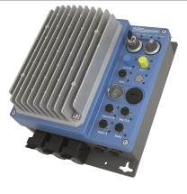
Image source: Würth Elektronik ICS
NORDAC LINK SK 250E-FDS frequency inverter

About Getriebebau NORD
Getriebebau NORD is a part of the globally operating NORD DRIVESYSTEMS Group, a 100% family-owned company. The NORD DRIVESYSTEMS Group is one of the market leaders in drive technology for mechanical and electronic solutions for decentralised drive control, and has been offering geared and electric motors, industrial gear units and electronic drive technology in different sizes and designs for over 50 years. Always in line with the highest quality and service standards as well as the latest technologies. Customers come from over 100 different industries.

Über Würth Elektronik ICS GmbH & Co. KG
Würth Elektronik ICS is a system supplier for electromechanical and electronic solutions for signal and electricity distribution, controlling functions, and display and operating solutions. ICS has been on the market as a member of the Würth Elektronik Group since 1984, and currently has about 350 employees, who generate an annual turnover of over €60 million. Its company headquarters are located in Niedernhall, Germany. There are subsidiaries of the company in France, the U.S., and India. Its main customers include well-known manufacturers of construction and agricultural machinery, as well as commercial vehicles. Sectors such as industrial technology, renewable energies, and shipbuilding also benefit from products and services provided by ICS.
Würth Elektronik: more than you expect!
Further info at www.we-online.de/ics

More information:  Würth Elektronik ICS GmbH & Co. KG  Sandra Herter  Gewerbepark Waldzimmern  Würthstrasse 1  74676 Niedernhall  Germany  Phone: +49 7940 9810-1503  E-mail: sandra.herter@we-online.de  www.we-online.de/ics | Press contact:  HighTech communications GmbH  Brigitte Basilio  Brunhamstrasse 21  81249 Munich  Germany  Phone: +49 89 500778-20  Telefax: +49 89 500778-77  E-mail: b.basilio@htcm.de  www.htcm.de

