PRESS RELEASE
Relaunch of Würth Elektronik ICS’s Powerelements Online Shop
Added Features, Better Service, and More User-Friendly
Niedernhall (Germany), 2 July 2019 – Würth Elektronik ICS sells its wide range of Powerelements via the online shop. Since the relaunch of its shop in May 2019 customers now enjoy an updated, responsive design, an upgraded product search function, and enhanced customer service that includes real-time answers to their questions.
Powerelements are robust, reliable power supply terminals for PCBs. They feature a high current carrying capability. Würth Elektronik ICS offers these high current contacts in press-fit technology or for THT and SMT assembly for sale through its online shop.
Updates to user interface make it more user-friendly
The streamlined user interface (UI) with optimised image display makes it easier for customers to navigate in the online shop. The design is responsive to enable users to navigate with ease within the shop on a variety of devices, such as PCs, tablets, and smartphones. The central element of the new online shop is the dynamic and intuitive product search function. Aided by a smart search server, this increases the quality of the search results to make it easier for customers to select the right Powerelements.
Many new features for registered users
There are other benefits and features available to customers who register on the online shop. After logging in, for example, information on product availability, ordering options, as well as a personal dashboard are shown. There is also a price inquiry function for registered customers who are placing high-volume orders for their projects. In addition to this, the customer’s personal contact partner is also displayed.
Better customer service in real time
Developers can download CAD data and order free samples on the online shop. If the samples are available, they can be delivered quickly - in many cases within 24 to 48 hours. To further improve customer service, Würth Elektronik ICS also provides a live chat function available to all visitors to the new online shop. Questions about products and the ordering process are answered here in real time. In this way, and true to the motto, “More than you expect,” the Powerelement team at Würth Elektronik ICS supports its customers from the initial idea to the launch of production.

Available images
The following images can be downloaded from the Internet in printable quality: http://www.htcm.de/kk/wuerth_ics
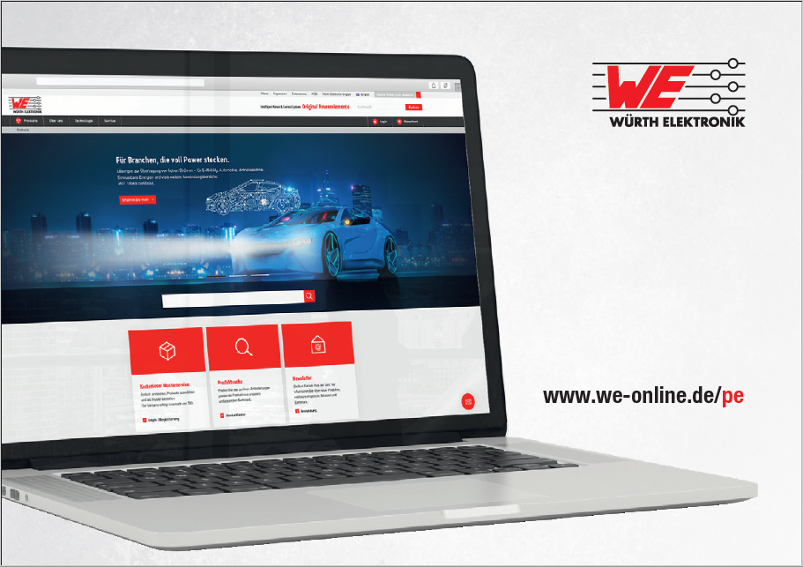Image source: Würth Elektronik ICS

New power online shop with optimized product search and enhanced customer service.

About Würth Elektronik ICS GmbH & Co. KG
Würth Elektronik ICS is a system supplier for electromechanical and electronic solutions for signal and power distribution, control, and display and operating solutions. ICS has been on the market as a member of the Würth Elektronik Group since 1984, and currently has about 400 employees, who generate an annual turnover of over €75 million. Its company headquarters are located in Niedernhall, Germany. There are subsidiaries of the company in France, the U.S., and India. Its main customers include well-known manufacturers of construction and agricultural machinery, as well as commercial vehicles. Sectors such as industrial technology or renewable energies also benefit from products and services provided by ICS.
Würth Elektronik: more than you expect!
Further info at www.we-online.com/ics

More information:  Würth Elektronik ICS GmbH & Co. KG  Sandra Herter  Gewerbepark Waldzimmern  Würthstrasse 1  74676 Niedernhall  Germany  Phone: +49 7940 9810-1503  E-mail: sandra.herter@we-online.de  www.we-online.com/ics | Press contact:  HighTech communications GmbH  Brigitte Basilio  Brunhamstrasse 21  81249 Munich  Germany  Phone: +49 89 500778-20  Telefax: +49 89 500778-77  E-mail: b.basilio@htcm.de  www.htcm.de

