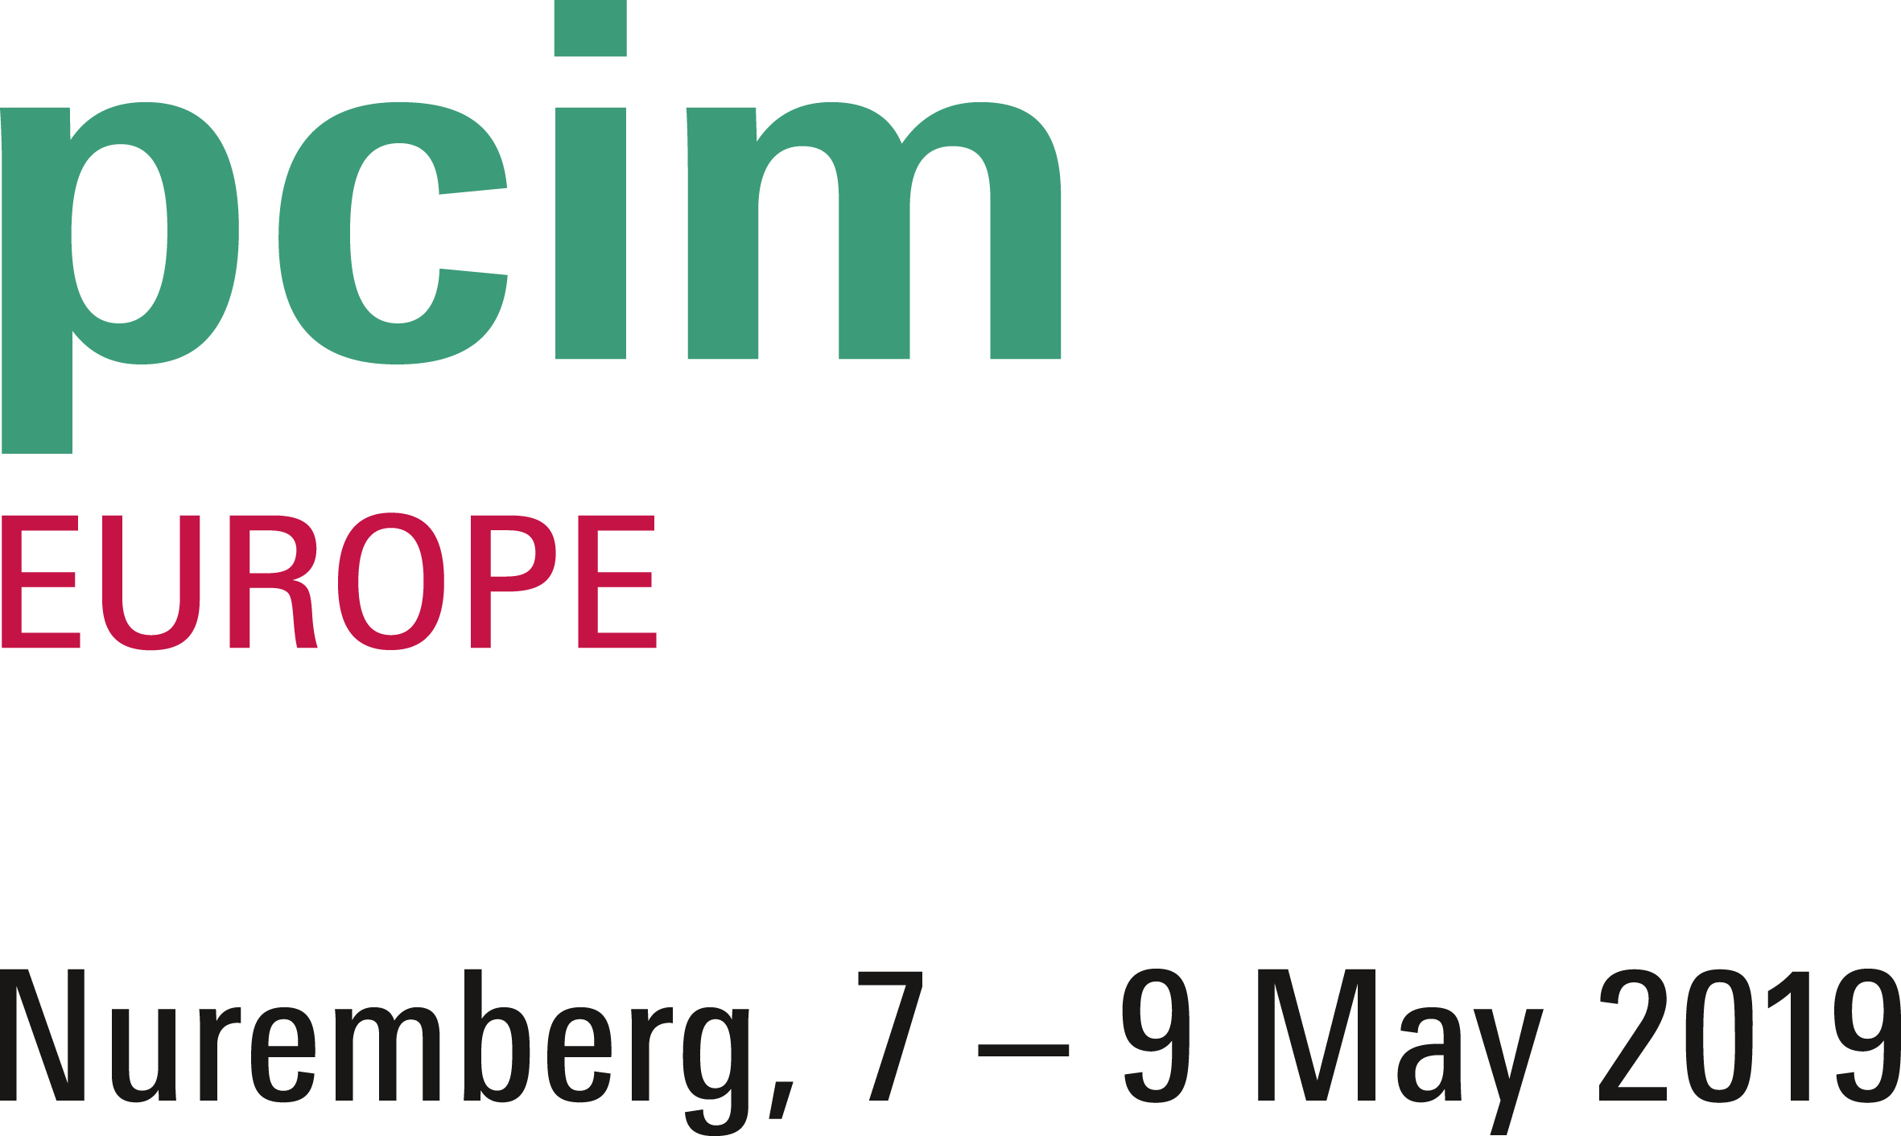
PRESS RELEASE
Würth Elektronik ICS to exhibit at PCIM 2019 in Nuremberg, Germany
Plug-in Powerelements for SMT assembly
Hall 6, Booth 206
Niedernhall (Germany), 30 April 2019 – Würth Elektronik ICS will exhibit at PCIM from 7 to 9 May 2019 (Nuremberg Exhibition Centre, hall 6, booth 206). Trade fair highlights will include its first plug-in SMT-mountable Powerelement, PowerBasket SMD, as well as its revamped online shop for Powerelements that boasts a new responsive design and user-friendly features. The Würth Elektronik ICS booth is also a station on the guided tour for e-mobility at the trade fair.
Würth Elektronik ICS will present the first ever pluggable Powerelements for SMT assembly in its Powerelements range, PowerBasket SMD. They will perfectly complement existing PowerBasket High Current Contacts, which are available in THT and press-fit versions. Products in the PowerBasket SMD series are lead-free and RoHS-compliant. They can be processed on conventional SMT lines and soldered using a convection or vapour phase system. PowerBasket SMD Powerelements are repeatedly pluggable. Compared to conventional systems, the design of the contact lamellas significantly reduces plug-in and extraction forces. It is possible to use multiple contacts at once when combined with a position tolerance of up to 0.6 mm. They are particularly suitable for use as board-to-board connectors. A special alloy used in the products also allows them to be used in high ambient temperatures.
The company will also present its new optimised online shop just in time for PCIM. This is where customers will be able to discover the largest range of Powerelements on the market. The new online shop stands out due to its simplified user interface, intuitive product search, live chat for better customer service and the option for developers to order free samples.
Guided tour on e-mobility
As a supplier of components and system solutions that are perfect for use in high current and high voltage applications, Würth Elektronik ICS considers PCIM, with its focus on e-mobility, to be the ideal platform for showcasing its products and services. The Würth Elektronik ICS booth will be one station on the guided tour at the trade fair. Registered visitors will be presented solutions revolving around the topic of e-mobility in the morning and afternoon of each day of the trade fair.

Available images
The following images can be downloaded from the Internet in printable quality: http://www.htcm.de/kk/wuerth_ics
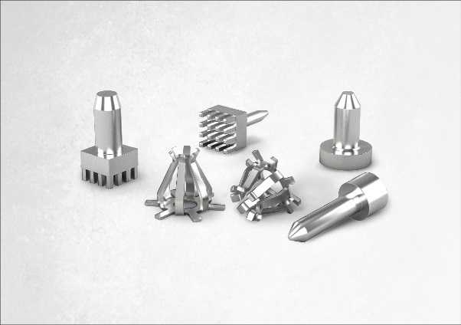Image source: Würth Elektronik ICS
Würth Elektronik ICS will present its first pluggable Powerelement for SMT assembly, PowerBasket SMD, at PCIM.

About Würth Elektronik ICS GmbH & Co. KG
Würth Elektronik ICS is a system supplier for electromechanical and electronic solutions for signal and power distribution, control, and display and operating solutions. ICS has been on the market as a member of the Würth Elektronik Group since 1984, and currently has about 400 employees, who generate an annual turnover of over €75 million. Its company headquarters are located in Niedernhall, Germany. There are subsidiaries of the company in France, the U.S., and India. Its main customers include well-known manufacturers of construction and agricultural machinery, as well as commercial vehicles. Sectors such as industrial technology or renewable energies also benefit from products and services provided by ICS.
Würth Elektronik: more than you expect!
Further info at www.we-online.com/ics

More information:  Würth Elektronik ICS GmbH & Co. KG  Sandra Herter  Gewerbepark Waldzimmern  Würthstrasse 1  74676 Niedernhall  Germany  Phone: +49 7940 9810-1503  E-mail: sandra.herter@we-online.de  www.we-online.com/ics | Press contact:  HighTech communications GmbH  Brigitte Basilio  Brunhamstrasse 21  81249 Munich  Germany  Phone: +49 89 500778-20  Telefax: +49 89 500778-77  E-mail: b.basilio@htcm.de  www.htcm.de

