PRESS RELEASE
Würth Elektronik ICS presents the new REDline Power Box M Plus
Robust solutions for power distribution in mobile machines
Niedernhall (Germany), 28 November 2019 – Würth Elektronik ICS has been successfully developing system solutions for power distribution, signal transmission, and control of functions in commercial vehicles and mobile machines for over 20 years. With the REDline Power Boxes product family the company offers a platform concept with compact, customer-specific adaptable power distribution solutions in standard housings that meet a wide range of different requirements. With the M Plus, Würth Elektronik ICS now presents a new version of the series.
The REDline Power Box M Plus is perfect for customers who want to place the power distribution unit between the engine area and the driver’s compartment in their vehicles, and are therefore looking for a solution that will work in particularly challenging environments. The M Plus can operate in temperatures between -40 °C and +110 °C. The optional exterior MEGA fuse gives you the ability to create a protected power line and to keep the components within the box safe. Compliance with the IP66 and IP69K protection classes ensures that the M Plus is dust-tight and is even capable of withstanding high-pressure water jets. It is fitted with a 31- or 39-pin LeavySeal connector and offers up to four power connections.
A robust system solution that is highly cost-effective
REDline Power Boxes stand out due to their excellent durability and cost-effectiveness. The wide variety of standardised housings is a further advantage of the platform concept. The modular box architecture and the individually configurable circuit board in the REDline Power Boxes ensure that customer-specific projects can be implemented simply and fast. Therefore, development times and costs are significantly reduced and installation and maintenance are simplified. Würth Elektronik ICS also offers its customers an impressive service concept and supports them from the initial idea to the launch of production.

Available images
The following images can be downloaded from the Internet in printable quality: http://www.htcm.de/kk/wuerth_ics
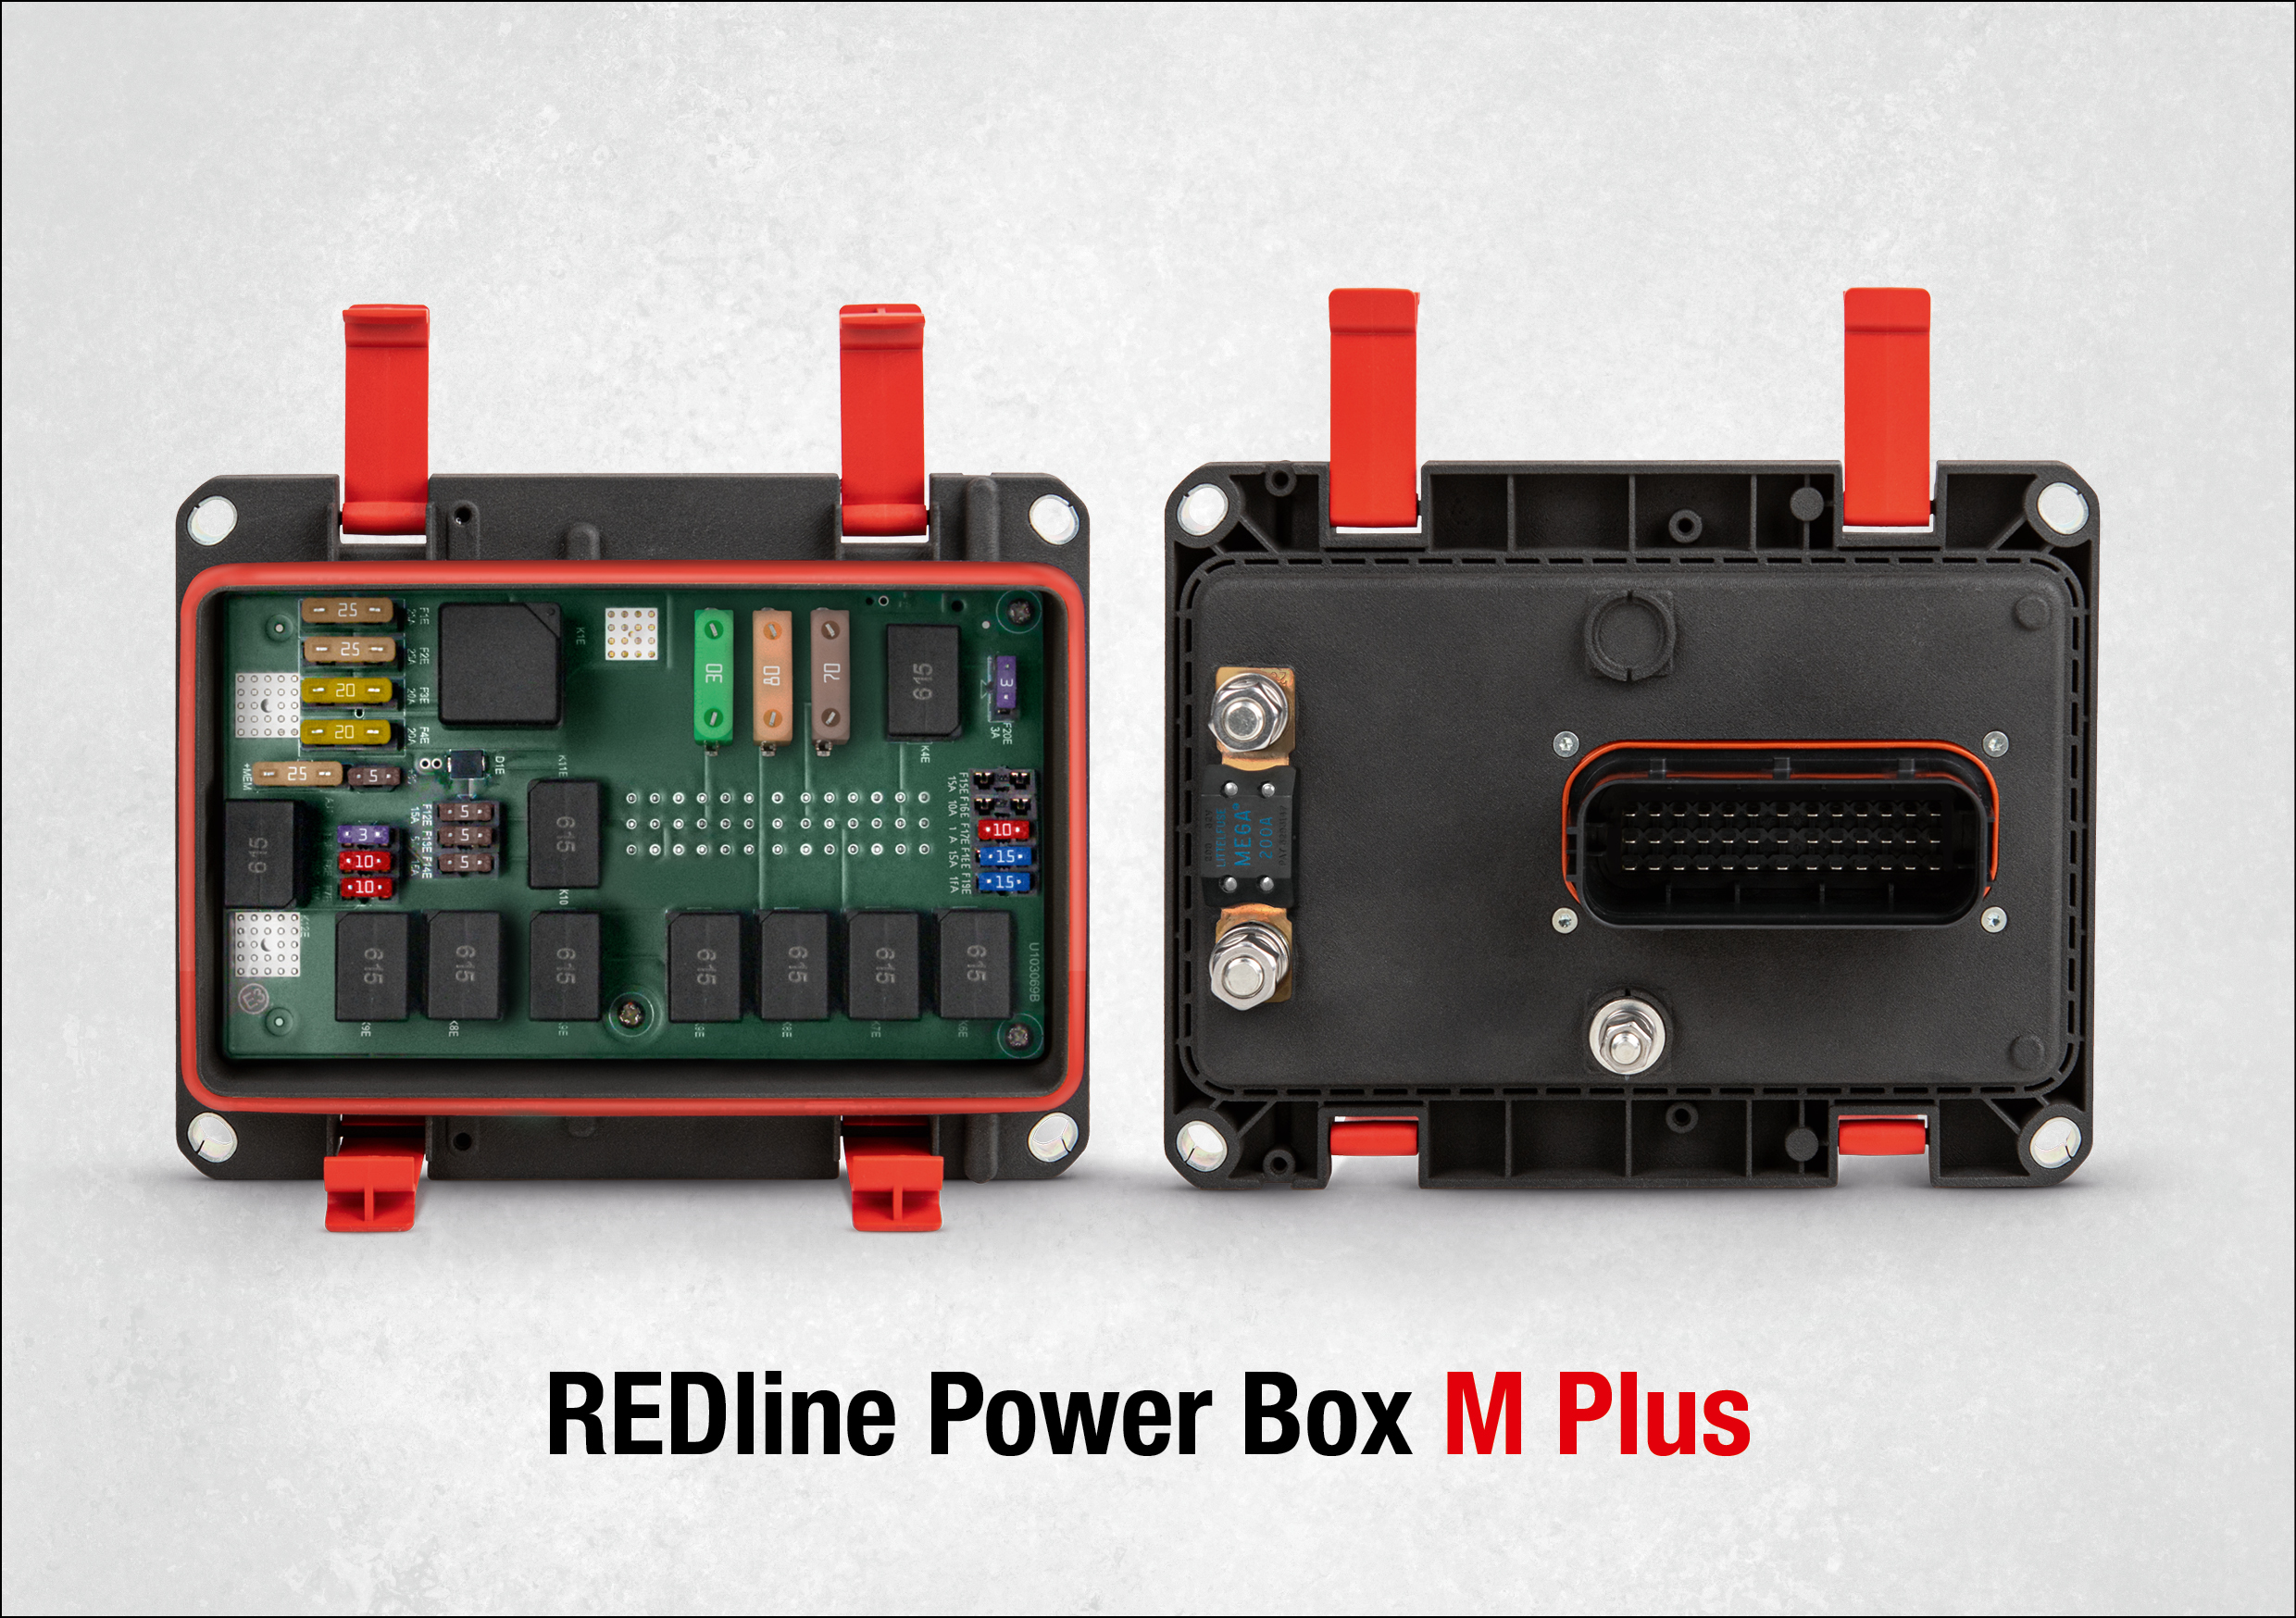
Image source: Würth Elektronik ICS
REDline Power Box M Plus – power distribution solution in standard housing

About Würth Elektronik ICS GmbH & Co. KG
Würth Elektronik ICS is a system supplier for electromechanical and electronic solutions for signal and power distribution, control, and display and operating solutions. ICS has been on the market as a member of the Würth Elektronik Group since 1984, and currently has about 400 employees, who generate an annual turnover of over €75 million. Its company headquarters are located in Niedernhall, Germany. There are subsidiaries of the company in France, the U.S., and India. Its main customers include well-known manufacturers of construction and agricultural machinery, as well as commercial vehicles. Sectors such as industrial technology or renewable energies also benefit from products and services provided by ICS.
Würth Elektronik: more than you expect!
Further info at www.we-online.com/ics

More information:  Würth Elektronik ICS GmbH & Co. KG  Sandra Herter  Gewerbepark Waldzimmern  Würthstrasse 1  74676 Niedernhall  Germany  Phone: +49 7940 9810-1503  E-mail: sandra.herter@we-online.de  www.we-online.com/ics | Press contact:  HighTech communications GmbH  Brigitte Basilio  Brunhamstrasse 21  81249 Munich  Germany  Phone: +49 89 500778-20  Telefax: +49 89 500778-77  E-mail: b.basilio@htcm.de  www.htcm.de

